OCCASIONAL NOTES
S t r a n g e r s R e s t E v a n g e l i c a l C h u r c h

Should Every Christian Receive a Personal Baptism of the Holy Spirit after Conversion?
“This only would I learn of you, Received ye the Spirit by the works of the law, or by the hearing of faith?”
Galatians 3:2

On 24th March 2023 I completed ten years as minister of Strangers Rest. I feel honoured to have been able to serve the Lord as a minister for this period and so grateful for his help in discharging this responsibility which has not been without its challenges. I am very grateful to all those who have served with me during this time in whatever capacity. Please pray that the Lord would continue to give me grace to serve Him in this role for the future.
Many of those who read these notes will know my predecessor, Gerald Daley. He had a background in an Elim Pentecostal Church in Wales but he left the Pentecostal Movement and subsequently embraced Reformed Theology. I remember that on one occasion in 2012 or early 2013, he remarked to me that he could not understand why I was not reformed because he drew so much comfort from its doctrines. At the time I remember thinking that it was because I was Pentecostal which is where I derived my comfort from and where I thought he should be getting his from as well. I have come to the conclusion that Gerald was right to embrace the reformed faith and to reject Pentecostalism and the Charismatic Movement and I have been wrong.

Purpose
My purpose in this article is to explain why I have come to see the Pentecostal distinctive of needing a personal post conversion baptism of the Holy Spirit evidenced by speaking in other tongues/or by some other supernatural manifestation as mistaken.

Tribute to My Pentecostal Brethren
However, before I explain my change of mind on this issue I would like to pay tribute to the
many godly men and women I met in the movement and their genuine desire to seek the Lord and to be obedient to Him, all of whom outshone me. So, while this is an important matter to understand correctly, it is not necessarily something that our salvation depends upon and therefore not something that should prevent believers on either side of the divide still continuing to enjoy fellowship with one another on those matters upon which they agree. I am grateful for my exposure to the movement which has left me acknowledging the importance of having a zeal to know the Lord, to be true to the whole counsel of God contained in the scriptures, to seek God earnestly in prayer and to expect God to speak to us and guide us personally through life. While the Lord, in His Sovereign Purpose, has caused me to enter and then leave the Pentecostal Movement, I can see His Good Hand in these particular providences.

My Journey into and out of the Pentecostal Movement

My spiritual journey into the charismatic movement began shortly after my conversion when I was given “Chasing the Dragon” by Jackie Pullinger to read by a friend who had guided me through the first steps of my Christian life while studying to be ordained at Durham University. I duly read the book when I was travelling around India. I was struck by her description of speaking with other tongues and the effect it apparently had on the drug addicts she had worked with in the Walled City in Kowloon on the mainland side of Hong Kong. I wanted this gift myself. Following my return to Durham I decided that I wanted to spend the summer working with Jackie Pullinger in the Walled City in Hong Kong. The introductions were made and Jackie kindly allowed me to join her for five weeks in the summer of 1984. Before I went I decided I needed to be filled with the Holy Spirit and speak in tongues and so my friend who was studying to be ordained arranged a group of people to pray over me as I knelt or sat in the midst of them. They placed their hands on my and started speaking in their own special languages and asked me to join them. Quite quickly I found myself joining in with what I thought was a language of my own. When I walked back to my college after they had prayed over me I remember that my vocal chords felt strained as I was using vowels and sounds that were new to me. This reinforced my view that I had indeed received the biblical gift of tongues although I remember the ordinand express his disappointment that when he went to Japan to teach English as a foreign language, his tongue was not Japanese. This in fact is a rather significant point that I will mention again later.
I duly went out to Hong Kong in the summer of 1984 to spend time with Jackie Pullinger. There I saw her work in action and it seemed a very impressive mission with young men and women being set free from their heroin addictions by their faith in the Lord Jesus and through praying with tongues.
I was also baptised in the South China Sea which was a very special occasion where I really felt as though, as I went under the waters of baptism, that this was what it would be like to be in my grave before coming up again, reflecting the resurrection life of Christ in every believer (Romans 6:3-5).
I returned to university that October convinced of the truth and reality of the Charismatic Movement. I became partly involved in a church called St Margaret’s which was a high Anglican Church but whose minister also spoken in tongues. I would go there, speak in tongues and interpret. I was also part of a prayer group of students where we spoke in tongues in public and interpreted ourselves.
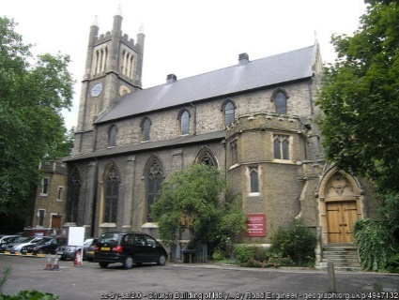
After university I spent seven years in the army and during my time in London I committed to attending Holy Trinity Brompton in central London. I helped out on a number of Alpha Courses and attended a leaders course to run a pastorate. During that course I remember singing in tongues but also questioning the leader, why we did not follow 1 Corinthians 14 and only allow 2 or 3 words of prophecy/tongues in a meeting. He did not seem to think that this restraint was necessary which surprised me at the time.
In 1994 the so-called Toronto Blessing arrived at the church where I was worshipping. At first I embraced this new “move of the Spirit” but I had my concerns. People were barking like dogs after the service. One lady was so taken up with the experience that she developed a tear in the bowel as a result of dehydration. One man spoke at a large summer gathering but could not control involuntary twitchings which he put down to the Holy Spirit. I too experienced dramatic bodily movements and I feared that I might end up finding myself with some affliction I could not control. I was taken aside by friends who had very real concerns about the movement and in the end I realised that what I was experiencing was not scriptural.
Around that time I was introduced to Stroud Green Christian Assembly, a traditional Pentecostal Church in North London belonging at the time to Assemblies of God. It came into existence following a crusade led by Smith Wigglesworth in Finsbury Park in the 1920s. I remember that one of the godly old ladies had told the minister that a man with a hat would soon join the congregation. At the time I regularly wore a trilby.
I was struck by a seriousness to seek God and biblical teaching that was much deeper than what I was used to. I discovered that the pastor sought the Lord for the word to preach on and when I first arrived I was struck by the theme of deception that was so relevant to what I had experienced before. I was also struck by time spent in prayer by the pastor, the days of prayer we had as a church and the necessary commitment to the meetings as part of our discipleship. There was a seriousness to know and to do the Lord’s Will that I had not previously known.
I spent 17 years at this church and was grateful of the teaching I received there and the exposure I had to the history of Assemblies of God. For instance, I had the privilege of meeting one man who knew all the founders of the movement and then his nephew who became a good friend for many years until he sadly died of cancer in 2015.
In terms of the use of the spiritual gifts while I was at Stroud Green, they were surprisingly few and far between. Indeed, I was one of the most prolific tongues speakers in church and if I am honest I was not convinced that my tongues were always profitable (and I don’t think the minister was [convincedeither). I remember on one occasion the minister suggesting that I stop speaking in tongues and wait until I knew I had a message and this is what I did. Sure enough at meeting words I didn’t recognise formed in my mind and I would give these out, invariably interpreting for myself although I was never entirely convinced that what I was doing was truly scriptural. There were nevertheless a handful of experiences that seemed to have been genuine. During my 17 years at Stroud Green we became increasingly isolated from the rest of the Assemblies of God movement because of their embrace of the modern excesses of Pentecostalism that we rejected. Eventually Stroud Green left to become independent.

Strangers Rest
In 2012 I moved to Strangers Rest where my assistant pastor, Ernie Amurao did not hold to a separate baptism of the Holy Spirit or to the continued use of the apostolic gifts. He was however very accommodating with me. We agreed in the end that tongues/prophecy would not be used during the main meetings but only in the prayer meetings provided nobody present objected. I continued to use the gift of tongues until last year although I was questioning whether my experience was truly biblical.
Towards the end of 2021 I met Don Underwood, a gracious gentleman, who once knew many of the founders of the Assemblies of God movement and would regale me with anecdotes of its early days. He used to exercise the gift of prophecy until the 1970s when he had cause to review the whole doctrine of the Baptism of the Holy Spirit and concluded the gifts of tongues, prophecy and healing were no longer gifts of the Holy Spirit that we should expect to see exercised today. He stopped speaking in tongues because he could not be sure that this was the same gift exercised in the New Testament. The more I thought about this the more I became convinced that he was right. One is reminded of Romans 14:23, that whatsoever is not of faith is sin. If you are not convinced, you must not do it!
This inevitably led me to question whether scripture really spoke of a separate baptism in the Holy Spirit for every believer.
I was also aware that I had not encouraged anyone to await a second baptism in the Holy Spirit since leaving my old Pentecostal Church. Indeed, I didn’t in my heart feel I should be telling them to seek such an experience which was difficult to believing in. I realised that I would have to decide once and for all what I did indeed believe about the doctrine of the Baptism of the Holy Spirit.
The first question I therefore decided to examine was whether or not scripture teaches that after conversion every person is to seek the Baptism of the Holy Spirit and that unless he receives it then he has not been empowered for service and was, in effect, an incomplete Christian. I had assumed for all my Christian life that the miraculous experiences of the Acts of the Apostles were normative for all believers. I now had to question whether this was indeed so and I have concluded that, while Christians need to continue to be filled with the Holy Spirit (Ephesians 5:18), we are not required each to undergo our own post-experience baptism as I assumed had been experienced in the Book of Acts. Instead the Baptism of the Holy Spirit occurs at conversion.

The Day of Pentecost
I had previously seen the sending of the Spirit on the day of Pentecost as merely empowering the disciples. If we look at Luke 24:49:- “And, behold, I send the promise of my Father upon you: but tarry ye in the city of Jerusalem, until ye be endued with power from on high.”
Viewed from this standpoint the sending of the Holy Spirit was merely an empowering of the disciples and other Christians but nothing more. I had been persuaded that it was always accompanied by speaking in tongues. This is because the 120 in the Upper Room spoke in tongues in Acts 2:4:- “And they were all filled with the Holy Ghost, and began to speak with other tongues, as the Spirit gave them utterance.” I didn’t pay sufficient attention to the fact that people spoke in languages recognised by other people as being real human languages. Instead I came to believe that the 120 in Acts spoke in a language that was instantaneously heard by the hearers in their own language.

The Samaritan Believers (Acts 8)
The next occurrence of the coming of the Holy Spirit is recorded in Acts 8, when Philip preached the Gospel in Samaria. This event would appear to have taken place from 4 to 5 years after the Day of Pentecost. This time lapse had completely escaped me before. This made me sit up and review whether there was something special about Samaria that set it apart from other places requiring this special visitation of the Holy Spirit.
You will recall that Samaria was part of the land inhabited by the 10 tribes that broke away from Solomon’s son Rehoboam. In 1 Kings 16:23 we read that Omri reigned for 12 years in Israel. In v24 it states that “he bought the hill Samaria of Shemer for two talents of silver, and built on the hill, and called the name of the city which he built, after the name of Shemer, owner of the hill, Samaria.” It became the capital city of Israel from which kings reigned. So, in 1 Kings 22:51 we read that Ahaziah the son of Ahab began to reign over Israel in Samaria in the seventeenth year of Jehoshaphat king of Judah. In 2 Kings 17 we read that the king of Assyria took Samaria and carried Israel away into Assyria and later in the chapter he brought men from Babylon, and replaced the people of Israel. However, this brought the wrath of God upon Samaria and the Lord sent lions among the people (v26) so one of the priests whom they carried away captive returned and taught the people how to fear the Lord. Ever since the religion of Samaria had been a mixture which led to the woman of Samaria asking the Lord Jesus in John 4 whether they should worship the Lord on that mountain or in Jerusalem (v20). The Lord’s answer in v21: “Woman, believe me, the hour cometh, when ye shall neither in this mountain, nor yet at Jerusalem, worship the Father.”
There were two reasons the Lord said that the worship would not be in Jerusalem only. The first was that Jerusalem and its Temple would be destroyed and not one stone left on another. The second was that distinctions of places of worship would become irrelevant as prophesied by Malachi 1:11:- “For from the rising of the sun even unto the going down of the same my name shall be great among the Gentiles; and in every place incense shall be offered unto my name and a pure offering: for my name shall be great among the heathen, saith the Lord of hosts.”
The coming of the Gospel to Samaria by Philip was the fulfilment of the prophecy that the Lord Jesus gave to the woman of Samaria and the prophecy in Malachi 1:11 and so was a particularly significant occasion. Note that when Philip came to Samaria he performed miracles and baptised people. In v6-8 we read: “And the people with one accord gave heed unto those things which Philip spake, hearing and seeing the miracles which he did. For unclean spirits, crying with loud voice, came out of many that were possessed with them: and many taken with palsies, and that were lame, were healed. And there was great joy in that city”.
After they believed they were baptised. However they did not receive the Holy Spirit in the same way as the apostles did at Pentecost. We read in v14: “Now when the apostles which were at Jerusalem heard that Samaria had received the word of God, they sent unto them Peter and John: who, when they were come down, prayed for them that they might receive the Holy Ghost: (for as yet he was fallen upon none of them: only they were baptised in the name of the Lord Jesus.)”
We do not know why the Holy Spirit did not come on these believers when they believed or why Philip was not able to impart this gift. It has been suggested that what is significant is that in verse 14 the apostles had heard that Samaria had received the Word of God. This was significant because they had, according to John Gill, only received the five books of Moses (the Pentateuch). Yet now they accepted the Gospel of the Lord Jesus preached by Philip so this was a very significant event.
However, the Holy Spirit had not fallen on them and so Peter and John prayed that they might receive the Holy Spirit (v15) which plainly led to extraordinary manifestations because Simon Magus was so impressed he offered the Apostles money in order to do the same (v19).
Note that Philip did not pray for the Holy Spirit to come. The gift was imparted by the laying on of hands by the apostles as we see in v17: “Then laid they their hands on them, and they received the Holy Ghost.” We do not know how many they laid hands on but if you go back to verse 5 we read that Philip went down to the city of Samaria and preached Christ unto them – that is all of them. Verse 6 suggests that a large number of people were converted – indeed we could go as far as to say that the majority of the city were converted. In verse 12 we read that when they believed Philip…” they were baptised, both men and women”. Interestingly we are not told that Philip baptised them all. I rather think it is unlikely that he was able to if the numbers were as great as implied. This implies that Peter and John did not lay hands on all the believers but only some – those to whom they were directed. This is what John Gill wrote in his commentary: “only on some they were directed unto by the Spirit of God; whom he had designed, and now would qualify for the work of the ministry, that so this new church, might be supplied with proper officers, pastors, and teachers, to feed them with knowledge and with understanding, and who might not only have ministerial gifts to qualify them for preaching the Gospel, but extraordinary ones, which would serve for the confirmation of it; and for this purpose the apostles, “both” of them, as the Arabic version reads, laid their hands on them: for it will not seem probable, that they laid their hands upon the women, on such an account; and it will hardly be received, that they should have laid their hands on Simon Magus, otherwise he would have received the Holy Ghost too; so that it seems a plain case, that imposition of hands was not used to them all.”
Is this a surprise? It is to me since I had assumed all believers had this extraordinary experience of the Holy Spirit when they believed. Yet we have to concede that in Acts 2 it was only those gathered in the upper room who received the Holy Spirit in this way – these were the one hundred and twenty (Acts 1:15:- “And in those days Peter stood up in the midst of the disciples, and said, (the number of names together were about an hundred and twenty)”). We know that the Holy Spirit fell upon them. Some suggest that the Holy Spirit only fell on the 12 apostles but that would assume that only the 11 apostles cast lots to choose between Matthias and Joseph called Barsabas (surnamed Justus) – whereas it would appear that all 120 were involved (Acts 1:15).

The 3,000 Converted on the Day of Pentecost
At the end of Acts 2 we read about the conversion of the 3,000 to whom Peter preached. In verse 38 Peter said to them: “Repent, and be baptised every one of you in the name of Jesus Christ and ye shall receive the gift of the Holy Ghost. For the promise is unto you, and to your children, and to all that are afar off, even as many as the Lord our God shall call.” Interestingly we are not told whether these 3,000 received the Holy Spirit in the same way as the 120. Scripture is silent on what, if any effects, accompanied their receiving the Holy Spirit. Indeed, it would appear that for these believers, responding to the preaching of Peter, who had received the Holy Spirit in a distinct manner, being one of the 120 gathered in the Upper Room, it would appear that conversion and receiving the Holy Spirit were one and the same event. So there was neither distinction nor delay between being converted and I venture to suggest that this was the experience of the Galatians as well which is why Paul wrote in Galatians 3:2:- “This only would I learn of you, Received ye the Spirit by the works of the law, or by the hearing of faith?” This is how we receive the Gospel, by the hearing of faith and not by tarrying as is encouraged in the Pentecostal Movement.

The Ethiopian Eunuch
In the same way scripture is silent about the Ethiopian Eunuch who was converted and baptised by Philip at the end of Acts 8:36-40:- “And as they went on their way, they came unto a certain water: and the eunuch said, See, here is water; what doth hinder me to be baptised? And Philip said, if thou believest with all thine heart, thou mayest. And he answered and said, I believe that Jesus Christ is the Son of God. And he commanded the chariot to stand still: and they went down both into the water, both Philip and the eunuch; and he baptised him. And when they were come up out of the water, the Spirit of the Lord caught away Philip, that the eunuch saw him no more: and he went on his way rejoicing.”
There is no mention of the Eunuch receiving the Holy Spirit in the way that the believers did in Samaria which suggests there was a particular reason for the manifestation of the Holy Spirit in Samaria which did not apply to the Ethiopian Eunuch.

Saul’s Conversion
When Paul was converted, Ananias laid hands on him in Acts 9:17:- “And Ananias went his way, and entered into the house; and putting his hands on him (Saul) said, Brother Saul, the Lord, even Jesus, that appeared unto thee in the way as thou camest, hath sent me, that thou mightest receive they sight, and be filled with the Holy Ghost.” Now let us read v18: “And immediately there fell from his eyes as it had been scales: and he received sight forthwith, and arose, and was baptised.” We do not read here of Paul at this time speaking in other tongues or prophesying although we do know that he did speak in other tongues since he said in 1 Corinthians 14:18 : “I thank my God, I speak with tongues more than ye all”. So, did Saul have a one or two stage conversion? The fact that he left the Road to Damascus a blind man, trembling and astonished, having asked the Lord what he should do, points to his conversion actually occurring when Ananias came to him and gave him back his sight. The moment his blindness and darkness were removed would seem to be the time of his conversion.
The next time we read of the Holy Spirit coming was in respect of Cornelius and his household in Acts 10:44:- While Peter yet spake these words the Holy Ghose fell on all them which heard the word. In the next verse we read: “And they of the circumcision which believed were astonished, as many as came with Peter, because that on the Gentiles also was poured out the gift of the Holy Ghost. For they heard them speak with tongues and magnify God.” Then answered Peter, “Can any man forbid water, that these should not be baptised which have received the Holy Ghost as well as we?”

Cornelius’s Household
What is interesting here is that the Holy Spirit fell on all of Cornelius’s household. Now I appreciate that there is a degree of controversy as to whether Cornelius’s household contained infants. My own assumption here is that the Holy Spirit only fell on those who were old enough to believe and not on babies. Now, just as Samaria was significant, so Cornelius’s household was significant because they were Gentiles and the falling of the Holy Spirit upon them marked a new phase in the spread of the Gospel. It seems that the giving of the Spirit at Pentecost was repeated in Cornelius’s household. When Peter reported this incident to the Jews at Jerusalem he said in Acts 10:15: “And as I began to speak, the Holy Ghost fell on them, as on us at the beginning.” Note that he did not say that the Holy Ghost fell on them as he has been falling on believers since the beginning. It suggests that the incidents reported in Acts were one-off, all in effect, part of the Day of Pentecost.

The Philippian Jailer and Lydia
It is also interesting to note that there is no record of the Holy Spirit falling on the Philippian Jailor in Acts 16: what we read in vv32-33 is: “And they spake unto him the word of the Lord, and to all that were in his house. And he took them the same hour of the night, and washed their stripes; and was baptised, he and all his, straightway.” The same is true earlier in the chapter with the conversion of Lydia in Acts 16:14-15:- “And a certain woman named Lydia, a seller of purple, of the city of Thyatira, which worshipped God, heard us: whose heart the Lord opened, that she attended unto the things which were spoken of Paul. And when she was baptised, and her household, she besought us, saying, if ye have judged me to be faithful to the Lord, come into my house, and abide there. And she constrained us.”

The Ephesian Believers
The next and last time that we hear of the Spirit coming upon believers is in Ephesus in Acts 19:1-7 as follows:
(1) And it came to pass, that, while Apollos was at Corinth, Paul having passed through the upper coasts came to Ephesus: and finding certain disciples, (2) He said unto them, Have ye received the Holy Ghost since ye believed? And they said unto him, We have not so much as heard whether there be any Holy Ghost. (3) And he said unto them, Unto what then were ye baptized? And they said, Unto John's baptism. (4) Then said Paul, John verily baptized with the baptism of repentance, saying unto the people, that they should believe on him which should come after him, that is, on Christ Jesus. (5) When they heard this, they were baptized in the name of the Jesus. (6) And when Paul had laid his hands upon them, the Holy Ghost came on them; and they spake with tongues, and prophesied. (7) And all the men were about twelve.
This event took place at least 23 years after the Day of Pentecost and is a significant passage because it brings us back to John’s baptism. Believers at Ephesus had only experienced John’s baptism which was an anticipatory baptism. That is that it anticipated the coming of the Lord Jesus Christ and was not a water baptism in the name of the Father, Son and Holy Spirit which was instituted by the Lord Jesus in Matthew 28:19:- “Go ye therefore, and teach all nations, baptising them in the name of the Father, and of the Son and of the Holy Ghost.” I assume that this was the baptism that his disciples used at the beginning of his ministry where we read in John 4:1 that “Jesus made and baptised more disciples than John”.
It would appear that these Ephesians had a defective understanding of the Gospel (like Apollos). Paul asked them whether they received the Holy Spirit “since they believed”. Lenski, in his commentary on Acts offers his own translation of this verse as follows: “Did you receive the Holy Spirit on coming to believe?”
I have been greatly helped by what Geoff Thomas said about this incident in “The Holy Spirit”:
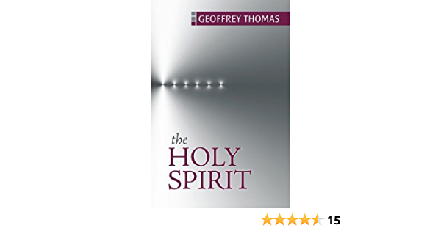
“We are told plainly that these people were disciples. Whenever that word is used in the book of Acts, it always refers to Christians. These people believed John the Baptist, who said the Messiah would soon come and baptize believers with the Holy Spirit. He showed Jesus of Nazareth to them, saying He was the Lamb of God who would take away the sins of the world.
The Ephesians believed this, but from that point their knowledge fizzled out. They did not know that the Holy Spirit had been poured out on the Church in Jerusalem on Pentecost. They did not know that, from that time on, every Christian had the Holy Spirit, or we might say that the Holy Spirit had every Christian. The Bible clearly says that the Christian life begins with new birth in the Spirit. John 3:8 says that we are “born of the Spirit.” Now if any man have not the Spirit of Christ, he is none of his,” Paul says in Romans 8:9. He also says to the troubled Church in Corinth, “Now we have received, not the spirit of the world, but the spirit which is of God” (1 Cor. 2:12). He adds, “We have all received him, all of you and me as well, the Spirit who is from God.” He also tells the Galatians that God’s promise to Abraham is now the Holy Spirit which had been poured out on the church in Jerusalem on Pentecost.
He also tells the Galatians that God’s promise to Abraham is now fulfilled, “that we might receive the promise of the Spirit through faith” (Gal. 3:14). The means by which we receive the Spirit is faith in Christ. We do not receive the Spirit by works, such as agonizing over our sin or good works or fasting, but by faith in the Saviour.”
This last point is important because there has been much teaching on receiving the baptism of the Holy Spirit that tells us that it is up to us to make the effort, by seeking God for hours for the experience and not something we receive by faith. You may have noticed that I said above that in 1984 “I decided I needed to be filled with the Holy Spirit,” as if it were up to me. Many Pentecostal churches held tarrying meetings which I presume was based on the example of the apostles before the Day of Pentecost. Yet those apostles were not instructed to seek the baptism of the Holy Spirit but to wait for the event which came at an appointed hour.
If “tarrying” is the way to receive the Holy Spirit, why did Paul say in Galatians 3:1-2: “This only would I learn of you, Received ye the Spirit by the works of the law, or by the hearing of faith?” Is this not identical to believing the Gospel?

Some Further Observations
In my view it is a mistake to take what happened on the Day of Pentecost as normative. To be fair Pentecostals themselves accept this view, but only up to a point. For example, one of the founders of the Assemblies of God, Donald Gee, wrote in “Wind and Flame”: “The dispensational significance of the gift of the Holy Spirit on the Day of Pentecost is fully recognised (Acts 2:33).”
Peter himself viewed the Day of Pentecost as the fulfilment of Joel 2:28-31 as he wrote in Acts 2:16-21:-
(16) But this is that which was spoken by the prophet Joel; (17) And it shall come to pass in the last days, saith God, I will pour out of my Spirit upon all flesh: and your sons and your daughters shall prophesy, and your young men shall see visions, and your old men shall dream dreams: (18) And on my servants and on my handmaidens I will pour out in those days of my Spirit; and they shall prophesy: (19) And I will shew wonders in heaven above, and signs in the earth beneath; blood, and fire, and vapour of smoke: (20) The sun shall be turned into darkness, and the moon into blood, before that great and notable day of the Lord come: (21) And it shall come to pass, that whosoever shall call on the name of the Lord shall be saved.
This then was the pouring out of the Spirit that was prophesied by Joel (see Acts 2:16).
This was also the event that the Lord Jesus predicted during his time on earth which James Buchanan summed up as follows in “The Office and Work of the Holy Spirit,” p50:-
After his resurrection, and immediately before his ascension to glory, he said to the apostles, “Behold I send the promise of my Father upon you: but wait in the city of Jerusalem, until you are endued with power from on high.” “And being assembled together with them, he commanded them that they should not depart from Jerusalem, but wait for the promise of the Father, which,” he says, “you have heard from me. For John truly baptized with water; but you will be baptized with the Holy Ghost not many days from now.” And “you will receive power after the Holy Ghost has come upon you; and you will be witnesses to me.” (Luke 24.49; Act 1.4, 8).
The Lord Jesus pointed to the Day of Pentecost as being the fulfilment of John’s prophesy that the Lord Jesus would baptise with the Holy Ghost and with Fire. The sound of a mighty rushing mighty wind inevitably points us back to Ezekiel 37 and the wind that gave life to the dead bones in Ezekiel’s vision as of course the conversion of the 3,000 that same day also points back to this vision. The tongues of fire that rested on those gathered in the Upper Room also suggest this was the fire that John spoke about.
This event was to be the crowning evidence that the work of redemption was complete since the Holy Spirit was not to be given until the Lord Jesus had been glorified as the Lord Jesus said himself in John 7:37-39:-
“In the last day, that great day of the feast, Jesus stood and cried, saying, If any man thirst, let him come unto me, and drink. (38) He that believeth on me, as the scripture hath said, out of his belly shall flow rivers of living water. (39) (But this spake he of the Spirit, which they that believe on him should receive: for the Holy Ghost was not yet given; because that Jesus was not yet glorified.)”
The Day of Pentecost, was the day in which the New Testament Church was inaugurated. This was the Day that the Lord sent his Spirit to the Church to be with them forever (John 14:16). He had been with the disciples because He was in Christ, but now He would be in them. (v17). He would teach them all things and bring all things to their remembrance (v26). Instead of dwelling in a temple in Jerusalem he would dwell in the hearts of his people (1 Corinthians 3:16). The Holy Spirit would now dwell in the body of believers and in each believer. It was a day of the greatest significance which is why it would be accompanied by supernatural signs. Let me quote from George Smeaton in his seminal work on The Holy Spirit:
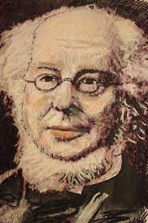
“A new revelation from God to man must needs be inaugurated with supernatural signs and miracles. As the Sinaitic Covenant was set up in a miraculous way, it is obvious that when the time arrived for its abrogation the new economy that superseded it must be ushered in by similar miracles. As God came down on the mount in a supernatural way, so did He bear witness to the apostles by signs and wonders and diverse miracles and gifts of the Holy Ghost (Hebrews 2.4); or, as some will have it, the glory of the Lord, the Shechina or fiery pillar, again appeared. The greatest event in all history, next to the incarnation and atonement, was the mission of the Comforter; for it will continue, while the world lasts, to diffuse among men the stream of the divine life. The Pentecost was the great day of the Holy Ghost, the opening of the river of the water of life. As Goodwin says: “He must have a coming in state, in a solemn and visible manner, accompanied with visible effects as well as Christ had, and whereof all the Jews should be, and were witnesses.” Not only so; there must be a Church which at its commencement should give the clearest indications of its heavenly origin. That was the great birthday of the Christian Church. The Christian economy was inaugurated amid supernatural manifestations which could not be questioned. When the reality came, the shadow passed away. The Jewish economy gave place before that which was to comprehend all nations. Now the New Covenant founded on better promises began (Jer 31:31; Eze 36.25).”
The coming of the Holy Spirit at the Day of Pentecost did not just come with external signs such as the speaking in tongues and prophecy but also with an abundance of the ministerial gifts and sanctifying influences.
It would seem that the external signs of speaking in tongues and prophesy were not present whenever conversions took place because we are not told about such signs when, for example, the three thousand were converted on the Day of Pentecost itself, when the Ethiopian Eunuch was converted, when Paul was converted (although we know he subsequently spoke in tongues and prophesied), or when Lydia and the Philippian Jailor were converted. This would suggest that it was not a prerequisite that every believer should manifest supernatural signs as proof of receiving the Holy Spirit. This is not something that I had previously considered. I had assumed that the Day of Pentecost, the coming of the Spirit to the Samaritan believers, to Cornelius’s household and the Ephesian believers in Acts 19 were a blue-print for the ensuing ages to mark a person who had been filled with the Holy Spirit.

Sealing of the Spirit
To that end it is worth noting that the sealing of the Holy Spirit in Ephesians 1:13 cannot in truth be the coming of the Holy Spirit as at Pentecost since not every believer received the supernatural gifts associated with the Day of Pentecost and the other events outlined in Acts where the Holy Spirit came upon specific believers in specific places. Furthermore the presence of the gifts of the Holy Spirit is not evidence that a person is going to heaven as is made apparent by the Lord Himself in Matthew 7:22-3:- “Many will say to me in that day, Lord, Lord, have we not prophesied in thy name? and in thy name have cast out devils? And in thy name done wonderful works? And then will I profess unto them, I never knew you: depart from me, yet that work iniquity.”

Ripple Effect
It would now seem to me to be more correct to see these subsequent actions of the Holy Spirit documented in Acts as a ripple effect from the Day of Pentecost to underline the reality that the Gospel had now gone to the Gentiles rather than as a blueprint for every believer requiring a separate baptism of the Holy Spirit following conversion. After all, where are we told to await the Baptism of the Holy Spirit as a post-conversion experience? Certainly it is true that the disciples were told to tarry in Jerusalem until they were endue with power from on high (Acts 24:49). As I have already mentioned, this has been taken by many Pentecostals as justification for holding “tarrying meetings” to await the Holy Spirit falling upon them. Yet, this verse was a specific instruction to a specific group to await a specific event in redemptive history, namely the inauguration of the New Testament Church. There was no tarrying when the Holy Spirit filled the Samaritan believers in Acts 8 or when the Holy Spirit fell on Cornelius’s household in Acts 10 or when the Holy Spirit fell on the Ephesians believers in Acts 19. Indeed, in the case of Cornelius’s household the coming of the Holy Spirit was even a surprise to Peter.

The Nature of Tongues
Key to this misunderstanding in my mind had been the nature of the Gift of tongues which I had previously assumed always accompanied the Baptism of the Holy Spirit. I assumed that the gift of tongues had always been what I had experienced, namely an ability to utter words that I did not understand which sounded like another language. But, as I mentioned earlier, how did I know that what I was saying was in fact what the Bible spoke about? This is especially relevant given that it is not just born again believers that speak in this kind of way. Here is a quote from the website Babbel.com:- “[Glossalia] has also occurred in other sects of Christianity (apart from Pentecostalism), as well as in other religions (and cults), such as paganism, shamanism and Japan’s God Light Association.”
The only illustration we have of the use of tongues in the scripture is on the day of Pentecost when we see that the tongues spoken by the 120 in the Upper Room were in languages understood by all those who were there. Let me quote from Acts 2:8-11:- “And how hear we every man in our own tongue, wherein we were born? Parthians, and Medes, and Elamites, and dwellers in Mesopotamia, and in Judaea, and Cappadocia…., we do hear them speak in our tongues the wonderful works of God.”
In Acts 10:46 we read that Cornelius and his household “spoke with tongues and magnified God”. How do we know they magnified God, unless they spoke in languages that could be understood? Therefore we must conclude that the languages spoken were known languages. (After all, the word for tongues in Greek, glōssa, is the same as the word for languages. In no part of Scripture is it necessary to understand it as referring to a non-human or supernatural language. All references to the gift of tongues can be understood in terms of the supernatural gift of the ability to speak a known human language.)
It now seems to me that the gift of tongues mentioned in 1 Corinthians 12:10 was a gift that enabled the apostles and the early church to spread the gospel in the early years without having to learn the language of the nation concerned. It is significant that Paul, when regulating the use of tongues in 1 Corinthians 14:21 referred back to Isaiah 28:11 and Deuteronomy 28:49 where it is clear that the use of a foreign tongue to instruct God’s people was a sign of divine displeasure and judgment.
In other words the Corinthians were being discouraged from using the gift of tongues to instruct their own congregations. Paul went on to remind the Corinthians of the correct use of tongues which was as a spiritual gift for the conversion of the Gentiles as the writers of Matthew Henry’s commentary on 1 Corinthians 14 describe:-
“Tongues were rather a sign to unbelievers than to believers, 1 Corinthians 14:22. They were a spiritual gift, intended for the conviction and conversion of infidels, that they might be brought into the Christian church; but converts were to be built up in Christianity by profitable instructions in their own language. The gift of tongues was necessary to spread Christianity, and gather churches; it was proper and intended to convince unbelievers of that doctrine which Christians had already embraced; but prophesying, and interpreting scripture in their own language, were most for the edification of such as did already believe: so that speaking with tongues in Christians assemblies was altogether out of time and place; neither one nor the other was proper for it.”
This interpretation is supported by 1 Corinthians 14:18-19 where Paul wrote:- “I thank my God, I speak with tongues more than ye all: yet in the church I had rather speak five words with my understanding that by my voice I might teach others also, than ten thousand words in an unknown tongues.” In my subconscious I assumed that Paul meant that he prayed in tongues more than all the Corinthians but that is not what he wrote. Also his use of tongues was outside the Church suggesting that he used this gift while on his missionary journeys to preach the Gospel.
Joseph Benson, an early Methodist minister and contemporary of John Wesley, confirmed this view when he quoted with approval the comments of James MacKnight, an 18th Century Church of Scotland Minister who wrote a commentary on the Epistles of St Paul in 1787 as follows:
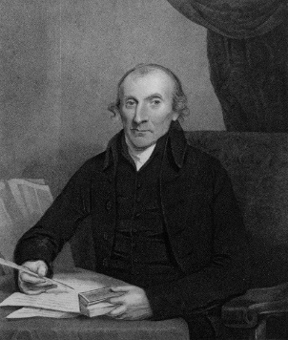
“As if he had said, I do not speak thus of foreign languages because I myself am deficient in them, for I must say, to the glory of that Being from whom all my gifts and talents are derived, I speak with tongues more than you all — More than the whole society taken together. “The apostle had this great variety of languages given him by inspiration, that he might be able immediately to preach the gospel to all nations, without spending time in learning their languages. But it must be remembered that the knowledge of so many languages miraculously communicated, was a knowledge for common use, such as enabled the apostle to deliver the doctrines of the gospel clearly and properly; and not such a knowledge of these languages as prevented him in speaking and writing from mixing foreign idioms with them, especially the idioms of his mother tongue. An attention to such trifles was below the grandeur and importance of the work in which the apostle was engaged, and tended to no solid use; these foreign idioms being often more expressive and emphatical than the correspondent classical phrases.” — Macknight.
This interpretation of these verses radically changes the meaning of this chapter. Unfortunately because I relied upon my own subjective experience of tongues which was to speak a language that no one could understand, I assumed that this must have been the gift of tongues that the New Testament was referring to, but I realise now that I was mistaken.
Part of my misunderstanding came from what I now see is a misinterpretation of 1 Corinthians 14:2-4 and also verses 14 and 15. I assumed that Paul was saying that a person praying in tongues was someone who prayed in a language that his spirit understood but that his mind did not, which means trying to distinguish the mind from the spirit as if they were independent entities. This meant that, although my mind did not understand what I was saying, I was speaking mysteries in my spirit that somehow edified me.

New Testament Mysteries
First the idea of speaking mysteries in my spirit needs examination. The Gospel is about revealed mysteries, not about closed mysteries as the following scriptures emphasise:
- Matthew 13:11:- “He (Jesus) answered and said unto them, Because it is given unto you to know the mysteries of the kingdom of heaven, but to them it is not given”;
- Romans 11:25:- “For I would not, brethren, that ye should be ignorant of this mystery, lest ye should be wise in your own conceits; that blindness in part is happened to Israel, until the fulness of the Gentiles be come in”;
- Romans 16:25:- “Now to him that is of power to stablish you according to my gospel, and the preaching of Jesus Christ, according to the revelation of the mystery, which was kept secret since the world began.”
Therefore the reference to a mystery may, as O Palmer Robertson wrote, be understood as communicating the truth that has been made known by divine revelation. However it cannot be communicated if it is in a language that no one understands. The revelational aspect of tongues is confirmed by verse 5;-
“for greater is he that prophesieth than he that speaketh with tongues, except he interpret, that the church may receive edifying.”
If indeed I am uttering mysteries to God that I do not understand then it is difficult to see how I can be edified. John Wesley’s comment on this verse is that, “only on the most favourable supposition” does a person edify himself.

Distinction between Spirit and Mind
We need secondly to address the distinction between spirit and mind. Where Paul speaks of his spirit praying while his understanding is unfruitful it suggests that praying in his spirit is without full rational understanding. Yet the human spirit and mind cannot so easily be separated, as we see in Mark 2:6-8 where the scribes were asking themselves in their hearts why the Lord Jesus was speaking blasphemy by telling the paralytic that his sins were forgiven when only God could forgive sins. Verse 8 is revealing because it says, “And immediately when Jesus perceived in his spirit that they so reasoned within themselves…” Therefore Jesus’s spirit contained more than just his emotional side. It was capable of reasoning and so it is a false dichotomy to suggest that man’s spirit (pneuma) is an irrational, purely emotional aspect of the person while his mind (nous) refers to his reasoning abilities.
This understanding is confirmed by verses 16 and 17 where Paul says to the one speaking in tongues: “Else when thou shalt bless with the spirit, how shall he that occupieth the room of the unlearned say Amen at thy giving of thanks, seeing he understandeth not what thou sayest? For thou verily givest thanks well, but the other is not edified.” The implication is that the speaker knows what he is praying – ie giving thanks and can say Amen to his own prayer (even though prayed in the spirit) but the other person, not understanding his language, cannot say Amen as well.
We should not forget the words of Peter in 2 Peter 3:16 where he warned against twisting those hard things that Paul wrote to their own destruction: “As also in all his epistles, speaking in them of these things; in which are some things hard to be understood, which they that are unlearned and unstable wrest, as they do also the other scriptures, unto their own destruction.”

Prophecy
Another area of controversy that has affected the Pentecostal and charismatic movements is prophecy.
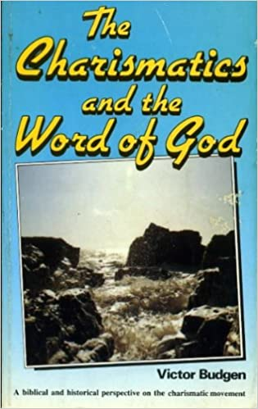
This is a gift that we hear much about today. I can think of a number in recent years that demonstrate the need for special discernment. There was an organisation that I was part of where one of the leaders once stood up and prophesied that Prince Charles would not be king. There was another leading charismatic who prophesied that Lake Taupo would disappear into the sea.
In his book, Charismatics and the Word of God, Victor Budgen quotes from a prophecy by David Wilkerson who was a highly regarded Pentecostal who had an effective ministry with drug addicts. In 1972 he quotes him saying, “I prophesy that within the next twelve months the Berlin Wall is coming down and there is going to be free access to all Iron Curtain countries including Russia. This was quoted from David Wilkerson’s Vision of Doomsday. Well, the Iron Curtain did come crashing down but that was not until 1989 which one cannot in any way attribute to the prophecy of David Wilkerson.

There is also a book I read which predicted an earthquake in the City of London in around about 1989 (Earthquake in the City by Paul Slennett). He forecast a financial earthquake that would “swallow up the whole City. Whole companies and city institutions will collapse in this earthquake, some never to rise again.” While it is true that there have been financial problems in the City nothing on the scale predicted in this prophecy have occurred. Without descending into great detail about the nature of biblical prophecy what we can say is that prophecies about future events in the Bible always come 100% true. However we have become accustomed to prophecies that always have an element of error which is excused on the basis that the instrument of the prophecy is a fallen, fallible human being. Yet consider for a moment the fallible instruments that God used in the Old Testament. He prophesied through apostate Saul, evil Balaam and even Balaam’s donkey yet the prophecies themselves were always 100% accurate.
Are New Testament prophecies to be considered any less accurate than Old Testament prophecies? Some have suggested that the wording of 1 Corinthians 14:29 where Paul writes, “Let the prophets speak two or three, and let the other judge” means that there was an expectation that New Testament prophecy would contain error. The comment on this verse in Matthew Henry’s commentary is as follows:
There might be false prophets, mere pretenders to divine inspiration; and the true prophets were to judge of these, and discern and discover who was divinely inspired, and by such inspiration interpreted scripture, and taught the church, and who was not - what was of divine inspiration and what was not. This seems to be the meaning of this rule. For where a prophet was known to be such, and under the divine afflatus, he could not be judged; for this were to subject even the Holy Spirit to the judgment of men. He who was indeed inspired, and known to be so, was above all human judgment.
It does not seem that those who wrote this part of Matthew Henry’s commentary considered that the standard was any different from that for Old Testament prophets. Yet, when I was in meetings where prophecies were given (including my own), this rigorous standard was not applied, often out of politeness and a desire not to offend or discourage a person who thought they had an inspired word from the Lord.
Another difficulty with prophecies that I heard, and even gave, is that when given in the first person, as many were, no one considered the effect of these prophecies on the doctrine of scriptural infallibility and the closure of the canon of scripture. Unlike in the time of Paul, when the canon was not closed, and so infallible utterances could be given because there was no limitation imposed by scripture. However, now the canon of scripture is closed, there can be no infallible utterance that adds to or subtracts from scripture (Revelation 22:18-19). This greatly limits the scope of what can today be prophesied and certainly rules out the style of the Old Testament prophets where doctrine was contained in the utterances, since any doctrine that is claimed to be spoken by the Lord must, in my view, offend Revelation 22:18-19.

Lack of Faith
There is an assumption that those who reject a separate baptism of the Holy Spirit and accompanying signs are lacking in faith by not believing that God can do today what He did in those early days as recorded in the Acts of the Apostles. On the face of it, this might appear to be the case and it was certainly my conviction for many years. The powerlessness of the Church is put down to a lack of faith and certainly there is a lack of faith in the Church but what is that lack of faith in? The danger of the Pentecostal position is that it distracts attention from the miracle of the new birth in favour of a focus on miraculous gifts of healing and prophecy etc. When the Lord Jesus said, in John 14:12 “He that believeth in me, the works that I do shall he do also; and greater works than these shall he do; because I go unto my Father”, Pentecostals assume this to be miraculous works. Yet no one has ever surpassed the Lord Jesus’s miracles. Where, in Church history do we read about 5,000 people being fed from five loaves and two fishes? Where do we read about men calming a storm, walking on water or even raising the dead? While there may have been some claims concerning raising from the dead, even these are few and far between. However, we must also remember what John wrote in the last verse of his gospel:- “And there are also many other things which Jesus did, the which, if they should be written every one, I suppose that even the world itself could not contain the books that should be written. Amen.” So can anyone out-do the miraculous works of the Lord Jesus? No one in history so far has managed to, so could it be that what he was referring to was not meeting man’s physical needs in miraculous healings and other such supernatural signs but instead to raising men from spiritual death to spiritual life? Let me quote from Geoff Thomas’s book, The Holy Spirit:
The man Christ Jesus preached the Sermon on the Mount on one mountain, at one time; He could not be anywhere else. He spoke in one Upper Room on a single evening prior to His crucifixion, but today the Spirit of Jesus Christ does the work of Jesus on a thousand mountains and in ten thousand rooms, all at the same time. The Spirit knows no physical limitations in duplicating the work of Jesus. Thus Jesus could say to the disciples that they would do greater works than He. For all they would do would be through the Spirit, the Vicar of Christ.
May I make it quite clear that I am not excluding the possibility of supernatural healings. God is able to perform them but that is not to be our focus. He has also provided the means by which we might be healed through the medical profession.

Focus on Experience
Another difficulty that has arisen is that the so-called “second baptism” has focussed attention on experience at the expense of doctrinal orthodoxy. It took me by surprise to find that many Pentecostals did not believe in the eternal sonship of Christ and indeed there is a whole movement called “Oneness Pentecostalism” which believes in baptism in the Name of Jesus only and which rejects the three Eternal Persons of the Trinity in favour of Modalism where there is one God who manifests himself in three modes of appearance. How is it that such people with such heterodox beliefs are yet still apparently blessed with a Baptism of the Holy Spirit?

Personal Testimony
I would like add a personal testimony about finishing using my “tongue”. It was my privilege to be interviewed by Nicky Campbell in May 2022 for a Podcast on “Five Live”. My past practice on such occasions when I was about to appear or indeed during an appearance on the media was to pray in tongues under my breath. On this occasion I decided I would not. At the end of the interview I realised that my mind had been much clearer because I had not been distracted by praying using strange words to which I did not know the meaning.

The Greatest Commandment – Role of the Mind
When the Lord Jesus was asked what was the greatest commandment in the Law he replied, “Thou shalt love the Lord thy God with all thy heart, and with all thy soul, and with all thy mind. This is the first and greatest commandment.” (Matthew 22:37). The problem with “praying in tongues” is that the mind is bypassed altogether which suggests that the act of praying in tongues is inconsistent with or even a breach of this first and greatest of all the commandments. It is hardly a reassuring biblical endorsement of speaking in tongues which has become so identified with the Pentecostal/Charismatic doctrine of a separate Baptism of the Holy Spirit.

Be Filled with the Spirit
I must finish the article with an emphasis on the need to be constantly filled with the Holy Spirit. We depend upon the Holy Spirit as believers and can do nothing without Him. I would have failed in this article if I appeared in any way to diminish the ministry of the Holy Spirit in the life of the believer. Peter is an instructive example. Despite being baptised with the Holy Spirit on the Day of Pentecost we read about him being filled with the Holy Ghost when he was before the Council in Jerusalem, which appears to have been a partial fulfilment of Luke 12:11:- “And when they bring you into the synagogues, and unto magistrates, and powers, take ye no thought how or what thing ye shall answer, or what ye shall say: for the Holy Ghost shall teach you in the same hour what ye ought to say.” We read the same thing happening to Paul when he opposed Elymas the Sorcerer in Acts 13:9: “Then Saul, (who is also called Paul,) filled with the Holy Ghost, set his eyes on him, and said, O full of all subtilty and all mischief, thou child of the devil, thou enemy of all righteousness ….” So effective was this rebuke (Elymas was blinded instantly) that the deputy of the country became a Christian (Acts 13:12).
Consider Stephen, a man full of faith and the Holy Spirit. We notice that this was not an instant experience but instead an abiding condition. His whole life was under the control of the Holy Spirit as ours should be also.
Consider the Lord’s promise in Luke 11:9-13 that we should ask, seek and knock in seeking the help of the Holy Spirit. These are instructions to the converted which speak of the absolute dependence that God’s people have on the Holy Spirit in every situation they find themselves in. We must get away from the idea that being filled with the Holy Spirit in any ways overrides a person’s mind. Instead He works through a person’s mind to sharpen and clarify the person’s thinking. Consider Ephesians 5:18-21:-
“And be not drunk with wine, wherein is excess; but be filled with the Spirit; Speaking to yourselves in psalms and hymns and spiritual songs, singing and making melody in your heart to the Lord; Giving thanks always for all things unto God and the Father in the name of our Lord Jesus Christ.”
The Spirit filled life will lead to a person rejoicing in the Lord in song as he finds in the psalms (note that psalms, hymns and spiritual songs are all the same words for the book of Psalms – the title to Psalm 67, for example includes all three of these descriptions). This of course brings us back to the day of Pentecost itself, “speaking the wonderful works of God”.
But it will also lead to a person being filled with the Holy Spirit as occurs when we read the Word of God and hear the Word of God preached – consider the parallel passage in Colossians 3:16:- “Let the word of Christ dwell in you richly in all wisdom; teaching and admonishing one another in psalms and hymns and spiritual songs, singing with grace in your hearts to the Lord”.
I would also make it clear, as I close, that we do not cease in any way to see the supernatural work of God in our lives. Being a Christian is to live a supernatural life. After all it started with a supernatural new birth whereby a man is raised from spiritual death to spiritual life by the mighty power of the Holy Spirit. Without this work nobody would have the ability or desire to believe the Gospel. May the Lord grant us each a greater measure of the Holy Spirit in our daily lives.

A Providential Leading
By Andrew and Ruth Price

The Word of God records the conversion of the pagan Naaman and his cure of leprosy. 2 Kings Ch 5. What was the oft overlooked providence which led to the Syrian's salvation? It had to do with a 'little maid' - a slave girl who was abducted from her mother country Israel and sold or gifted to the wife of Naaman. The girl who is not named but stands out for her faithfulness and her loyalty to her master and mistress, despite being cruelly uprooted from all she knew, made mention of the only one who could, humanly speaking, help her master in his terrible affliction of leprosy, namely the 'man of God', the prophet Elisha.
A few months ago one or two mutual friends of myself and Pastor Mark, made mention to me of a somewhat significant matter. Like the words of the Israelitish girl, the Lord was in it. In conversation, I was informed that the Strangers Rest Chapel had adopted a high view of the Psalms in public worship. This very much piqued my interest, as Ruth and myself had become weary of the trite and irreverent worship in the meeting place we were attending. We fervently believe that Psalm singing must be central in the true worship of God. This is evangelical, this is Reformed and above all this accords with the biblical pattern. So something which was said in passing was blessed to us and in early September we started attended the Reformed congregation in Shadwell. I may add, our attendance was greatly facilitated by the generous making available of the flat above the church building at weekends.
It is a good thing for the Lord's people to constantly reflect on the Lord's providences - great and small. Our Christian life should always be marked by a thankful spirit. Every day the Lord orders our lives for our wellbeing and for His glory - above all this can be seen in how the Lord graciously calls and saves us. Praise God ! Further, it is a good thing for us as Christians to be initiators in good, kindly and appropriate words and actions, so we are a blessing to others, although we may never know how or why. The Lord alone knows the beginning and end of all matters. Let's be ever on the lookout to do good and to speak well, not only in the 'household of faith', but in this world which the Lord has placed us in which Bunyan rightly calls a 'wilderness'. A mark of grace is that a Christian is a blessing to his brothers and sisters and a kindness to the unsaved. 'A word fitly spoken is like apples of gold in pictures of silver' Proverbs Ch 25 v11.

Baptism of Lauren and Chrisann Witter on Sunday 16th April 2023 By Lorna Witter

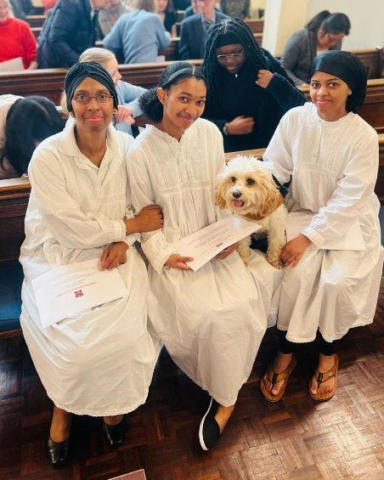
It was a cold winter’s Saturday morning in January 2018. A poor distraught widow was knocking on the door of Stranger’s Rest Mission Church waiting to attend the 7 am prayer meeting. There was no reply so she went to buy a hot chocolate from the nearby fast food outlet to keep warm. Praying silently for God to help her she knocked on the door again and was relieved to hear someone open the door. Praise the Lord for answering her prayers. She was warmly welcomed inside and it wasn’t long before others joined in praying to God for various needs. A hearty English breakfast was prepared and after refreshment and fellowship, the widow was on her way home to her children, thanking God in her heart for His care for her and her family.
L-R: Lorna, Chrisann and Lauren
“Ask, and it shall be given you; seek, and ye shall find; knock, and it shall be opened unto you”. John 7:7.
The church became the spiritual home for this mother and for the next 5 years she travelled on the overground bringing her youngest daughters with her. The church had a vibrant children’s ministry and they made friends and enjoyed the Bible Club on Friday evenings and singing hymns/psalms and listening to sermons on the Lord’s day.
“Yea, the sparrow hath found an house, and the swallow a nest for herself, where she may lay her young, even thine alters, O LORD of hosts, my King, and my God.” Psalm 84:3.
Sadly in August 2019 tragedy struck again with illness and lockdown, but the Lord gave sustenance through technology and perseverance in prayer. Unfortunately, many of the now teenage children became distant from church life and continuing to come, when so few remained required much grace.
“And He said unto me, My grace is sufficient for thee: for my strength is made perfect in weakness.” 2 Corinthians 12:9.
The power of God’s Word to help in times of trials saw many a troubled mind and broken heart comforted. The balm of Gilead was applied and prayer was as vital as breathing.
“For the hurt of the daughter of my people am I hurt; I am black; astonishment hath taken hold on me. Is there no balm in Gilead is there no physician there? Why then is not the health of the daughter of my people recovered?” Jeremiah 8:21-22.
God was at work in these tender hearts and gently carried His lambs in His loving arms. As the Scriptures were explained and an awareness of sin convicted their souls, lives were surrendered to Jesus for His forgiveness and care.
“He shall feed His flock like a Shepherd: He shall gather the lambs with His arm, and carry them in His bosom, and shall gently lead those that are with young.” Isaiah 40:11.
In November 2022 the Lord graciously and mercifully answered the prayers of the fatherless and their mother was spared the ravages of her disease and a measure of health restored.
There is indeed great rejoicing in heaven when sinners repent of their sins and in obedience to God’s Word get baptised.
The 16th April 2023 was a day of great rejoicing. The morning brought forth a beautiful pink sunrise with a promise of the warmth of God’s love for His chosen daughters.
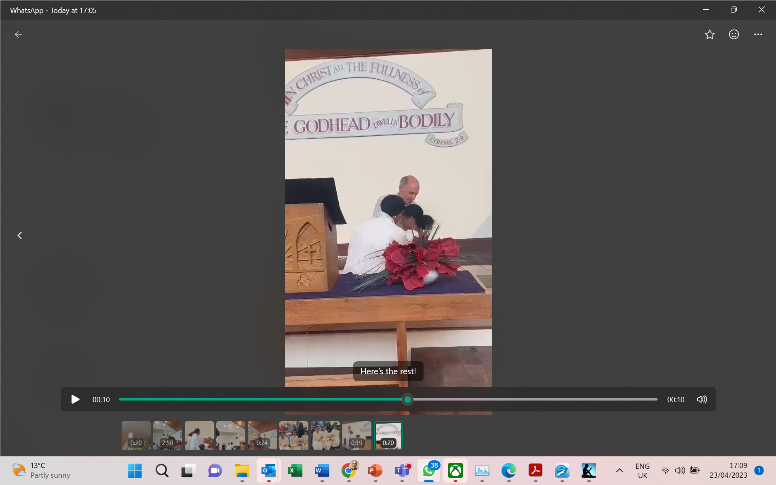
No sooner had we arrived at church we were greeted by visitors excited to see the baptism of these two teenage girls. White gowns were presented to us by a fellow Pastor and it wasn’t long before we were dressed and seated, waiting with anticipation for the service to start.
We had chosen the Psalms that had particular meaning for each of us. The singing of them was very powerful as we understood that Jesus Himself sings with His congregation and even rejoices over us with singing. Having a full house certainly added to the joy of singing praises to God Almighty for the great blessing of seeing repentant sinners obeying the Scriptures in being baptised.
Chrisann’s Baptism
The story of the young captive maid; who was used by God to tell her mistress that the Captain Naaman could be healed of his leprosy by the prophet Elisha in Samaria but he had to obey the command to wash in the river Jordan seven times to be made clean. This story was read and the Gospel message of needing our sins to be washed by the precious blood of Jesus Christ was woven into the sermon by Pastor Mark. The meaning of baptism was explained so that all present understood from the Scriptures why this was being done.
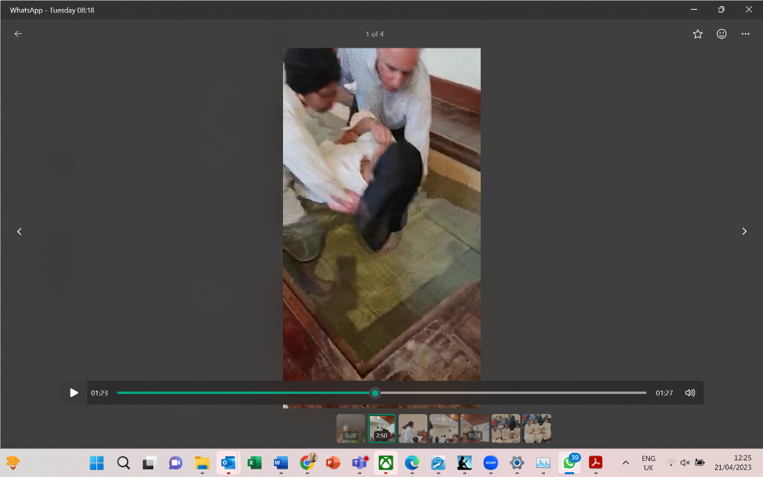
The personal testimonies of Lauren and Chrisann were then read out before the girls were invited to come into the font. They were asked the necessary questions proclaiming the dedication of their lives to Jesus and renouncing their sins and the world.
Lauren’s Baptism
I was given the privilege of helping Pastor Mark to baptise them and even though the water was very cold, the girls felt refreshed afterwards and soon warmed up. Psalms were sang to finish the service and Pastor Ernie prayed for God’s blessing on all that was said and done.
The Lord blessed us with much joy as family and friends joined us for a feast that was lovingly prepared by many who helped out behind the scenes. There was plenty for everyone and much left overs. Another answer to prayer.
Chrisann had written a poem which she read out after the meal.
We give thanks to God for a glorious day and time will tell of how this occasion for the Gospel message to go out to many people may fulfill His purposes and plans.
To think that this time last year I was walking through the valley of the shadow of death (in pain and agony with breast cancer) and now the Lord had bestowed His great mercy upon me and prepared a table before me in the presence of mine enemies…
To see and participate in my youngest daughters’ baptism on their late Dad’s birthday was a very special answer to many prayers offered up by the saints. We are very grateful to the Lord.
The effectual fervent prayer of a righteous man availeth much. James 5:16b
To God be the glory, great things He hath done.

I watch the Sunrise
💜Chrisann Witter💜

I watch the sunrise
Its tender glow giving even the smallest flower hope
remember the elements, how they breathe a new scope
So does the flower bloom, your season to blossom will arise
The most beautiful flowers grow in the arduous places which to us may be a surprise,

If you do not look you will never see,
Open your eyes witness the undimmed light of the Son,
One alone has the key to give true liberty

Keep running until the end of the great race
Keep climbing the mountain, until the top is your place
Keep praying until with Jesus you are face to face

When you are engulfed by loss, anxiety and difficult decisions
He has the key to free you from the doubting prisons
Spread your new wings, give them a try
Fly fly up high!
Above the clouds see the sunrise with your teary eyes
Farewell to the life you lived in a blur
The feeling of the Sunshine, can only hope stir

The closer you are, the brighter you will glow
The closer you are, the stronger you will grow
The closer you are, (His) promises you will know

But with peace comes pain as the closer you draw near
The more you can feel that thorny crown
But the end masterpiece is painted all so clear
I’m not only holding His hand I know also He is holding mine, I am now found!

In the dark valley I hear whispering lies all telling
In the dark valley upon stones I stumble, He holds me up as He said He would, His Word is sound, yes His Word is true
In the dark valley the river is up to my chin, it won’t stop swelling
In the dark valley I feel as though alone, but Jesus is still with me, I’m still with Him, let me remind myself anew,
I’m never alone when I’m with you!

The past may try to hinder you from moving forward, we might stagnantly dwell on it, or heedfully learn from it
Past present & future in God’s hands submit
His love is overwhelming, His presence is foretelling
I know I only need the Son to turn my sky’s to blue
Trust in Him and draw ever closer to Him, will you!
He can forgive you of all your sins, He is sovereign over all things,

So whether the weather is rainy, cloudy, stormy or sunny, you may know deep down there is a purpose and your mind He will renew, and the LORD Jesus Christ, will guide you all the way through!

💛Praise God always & forever

Praise and Prayer Requests
For Praise:
- For the Lord’s Keeping and Prospering the Work;
- For two families that have formed the bedrock of the children’s work this quarter;
- Please give thanks for the opportunity to preach the gospel to unbelievers at the funeral of 95 year old Albert who had been attending Strangers Rest for several weeks from a nearby nursing home;
- For Andrew and Ruth joining us in September;
- Please give thanks for the Christian men living in the flat above the church and for their weekly support of Strangers Rest;
- Continued Assistance from London City Mission for door to door evangelism.

For Prayer:
- Please pray for the baptism of two young ladies who have been coming to Strangers Rest since 2018 with both coming to faith during that time;
- Please continue to pray for good fruit from the outreaches;
- Please pray for the children of a local family that they would return to Strangers Rest regularly and be converted;
- Please pray for workers for the harvest field;



You are invited to our
146th Anniversary Service in Person and Online
EDWARD MALCOM
On Saturday 27th May 2023
At 2:30 pm

Details:
Zoom
Meeting ID: 910-993-1031; Password: 667012
Or call 0131 460 1196 using the above details.

YouTube
Strangers Rest
https://www.youtube.com/channel/UCUV3ZmDVydcAFtZ6TCLGliA

Editor: Mark Mullins (Minister)
Strangers Rest Evangelical Church, 131 The Highway, London, E1W 2BP; 0207 488 4427.
Services: Sunday Service 11:00am and 6:30pm; Wednesday Bible Study 7:00pm; Friday Children’s Bible Club 6:30pm, Sunday School 4:00pm.
www.strangersrest.org

? The Holy Spirit by Geoff Thomas. Reformation Heritage Books. Kindle Edition.

