Autumn 2022
S t r a n g e r s R e s t E v a n g e l i c a l C h u r c h

A Case for Singing Psalms in Public Worship (Part 2)
Mark Mullins (Minister)
Sing unto him, sing psalms unto him: talk ye of all his wondrous works
Psalm 105:2

OCCASIONAL NOTES

In the last edition of Occasional Notes I explained why I had become persuaded that the hymns we should be singing in the church are the Psalms which as we saw in the last notes are the Old Testament Church’s gift to the New. Why, I now ask myself, would I want to sing the uninspired words of man in place of the inspired words of God? Put like that, I have no difficulty in just singing from the Book of Psalms. In part 2, I would like to look at the Regulative Principle, the use of musical instruments as part of worship and finally at the history of psalmody.
The Regulative Principle
The regulative principle has been expressed in these three simple statements:
- We must not do anything that God forbids in His Word concerning His worship;
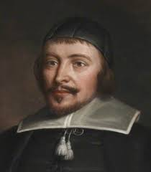
- We must do everything that God commands in His Word concerning His worship; and
- We must not add to or take away from what He commands or forbids in His Word concerning His worship.
The bedrock of the regulative principle is found in the Second Commandment: “Thou shalt not make unto thee any graven image, or any likeness of anything that is in heaven above, or that is in the earth beneath, or that is in the water under the earth. Thou shalt not bow down thyself to them, nor serve them...” (Exodus 20:4-5). This verse is interpreted to mean that the worship of God is to be exactly as God directs and no different which is what we find in Deuteronomy 12:32:- “What thing soever I command you, observe to do it: thou shalt not add thereto, nor diminish from it.” This verse provides the third statement of the regulative principle set out above.
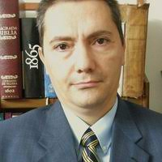
An example of adding to the command of God in worship is the sad tale of Nadab and Abihu which illustrates this principle. Leviticus 10:1 tells us that “Nadab and Abihu, the sons of Aaron, took either of them his censer, and put fire therein, and put incense thereon, and offered strange fire before the Lord which he commanded them not. And there went out fire from the Lord, and devoured them, and they died before the Lord.” Verse 3 continues: “Then Moses said to Aaron, “This is it that the Lord spake, saying, I will be sanctified in them that come nigh me, and before all the people I will be glorified. And Aaron held his peace.” The puritan, Jeremiah Burroughs (1599-1646), commenting on Leviticus 10:3 in his book, Gospel Worship, wrote this: “in God’s worship, there must be nothing tendered up to God but what He has commanded. Whatsoever we meddle with in the worship of God must be what we have a warrant for out of the Word of God … all things in God’s worship must have a warrant out of God’s Word. It must be commanded, it’s not enough that it is not forbidden. … Such things as seem to be very small and little to us, yet God stands much upon them in the matter of worship, for there is nothing wherein the prerogative of God more appears than in worship”.
Jorge Ruiz Ortiz helpfully identified a number of restrictions in the Old Testament:
- Sacrifices could only be offered at the place of the Lord’s appointment (Deuteronomy 12:1-14). The people were not permitted to offer them in the high places which became one of Judah’s sins (2 Kings 18:4);
- The priests responsible for the altar could only come from the tribe of Levi. Hence when Uzziah attempted to burn incense before the Lord leprosy rose up in his forehead (2 Chronicles 26:19);
- In Isaiah 1:12 the Lord, through Isaiah reprimanded the people for worshipping in a way God had not ordained: “who hath required this at your hand, to tread my courts” (Isaiah 1:12); and
- Uzzah’s death in 2 Chronicles 15:12-13 when he tried to steady the ark was as a result of not doing what God had commanded.
In the New Testament all the ceremonial laws have been fulfilled in the Lord Jesus Christ and so should not be reintroduced without diminishing the glory of the New. Hence Paul warned the Colossians, “Let no man therefore judge you in meat, or in drink, or in respect of an holyday, or of the new moon, or of the sabbath days: which are a shadow of things to come; but the body is of Christ”. Then there is Hebrews 7:12 and 18 and 8:13. Also Hebrews 10:1:- For the law having a shadow of good things to come, and not the very image of the things, can never with those sacrifices which they offered year by year continually make the comers thereunto perfect.
When it comes to worship we need to distinguish between the moral and ceremonial aspects of it. The worship of God is a moral requirement. Note that the inspired Song of Moses in Exodus 15 predated the giving of the Ceremonial Law on Mount Sinai. We will see more of this as we consider musical instruments. Before closing this section let me quote from John Knox, who spent most of his five years in exile in Geneva (1554-1559). This is what he had to say:
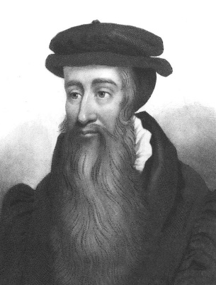
Disobedience to God’s voice is not only when men doeth widedly contrary to the precepts of God, but also when of good zeal, or good intent, as we commonly speak, men doeth anything to the honour or service of God not commanded by the express word of God … And that is principal idolatry when our own inventions we defend to be righteous in the sight of God, because we think them good, laudable, and pleasant We may not think us so free nor wise, that we may to unto God, and unto His honour, what we think expedient.
Then consider what John Owen wrote:
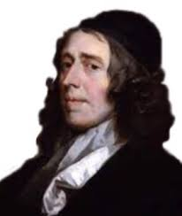
That the church hath power to institute and appoint anything or ceremony belonging to the worship of God, either as to matter or manner, beyond the orderly observance of such circumstances as necessarily attend such ordinances as Christ Himself hath instituted, lies at the bottom of all the horrible superstition, and idolatry, of all the confusion, blood and persecution, and wars, that have for so long a season spread themselves over the face of the Christian world.

Musical Instruments
Musical instruments, however, did not come until later. The first mention is in Numbers 10:10:- “Also in the day of your gladness, and in your solemn days, and in the beginnings of your months, ye shall blow with the trumpets over your burnt offerings, and over the sacrifices of your peace offerings; that they may be to you for a memorial before your God: I am the LORD your God.” In spite of Moses being ‘learned in all the wisdom of the Egyptians’ (Acts 7:20) – and no doubt familiar with the wide array of musical instruments in use in Egypt, yet the only musical instrument to be used in worship at the tabernacle was the trumpet.
We then move on to David’s time when, for the first time, the worship of God became centralised in Jerusalem. This meant that the role of the Levites carrying the tabernacle and its utensils had come to an end. In 1 Chronicles 23:25-26 we read: “For David said, The LORD God of Israel hath given rest unto his people, that they may dwell in Jerusalem for ever: And also unto the Levites; they shall no more carry the tabernacle, nor any vessels of it for the service thereof.”
In 1 Chronicles 16:4-6 specific roles were given to individuals in relation to the playing of musical instruments:
And he appointed certain of the Levites to minister before the ark of the LORD, and to record, and to thank and praise the LORD God of Israel: (5) Asaph the chief, and next to him Zechariah, Jeiel, and Shemiramoth, and Jehiel, and Mattithiah, and Eliab, and Benaiah, and Obededom: and Jeiel with psalteries and with harps; but Asaph made a sound with cymbals; (6) Benaiah also and Jahaziel the priests with trumpets continually before the ark of the covenant of God.
It is significant that these changes were made by David in response to specific direction from the Lord as we see in 1 Chronicles 28:19:- “All this, said David, the Lord made me understand in writing by his hand upon me, even all the works of this pattern.”
Two hundred years later we find that Jehoida restored the offerings in the temple under the control of the Levitical priests, “with rejoicing and singing according as it was established by David” (1 Chronicles 23:18).
Hezekiah carried out reforms a hundred years later and was careful to carry them out in line with the word of God which involved using only the instruments that David had appointed which were referred to in 1 Chronicles 16:42 as “musical instruments of God”. It is worth quoting the passage describing Hezekiah’s reforms in full because it emphasises that these instruments were appointed by God: “And he stationed the Levites in the house of the Lord with cymbals, with stringed instruments and with harps, according to the commandment of David, of Gad the King’s seer and of Nathan the prophet: for so was the commandment of the Lord through his prophets. The Levites stood with the instruments of David, and the priests with the trumpets” ( 2 Chronicles 29:25-26). We should note that God commanded Gad and Nathan (the prophets) who in turn commanded David. This form of worship was then adopted by Solomon and it became the normal practice in succeeding centuries (2 Chronicles 8:14 – “And he appointed, according to the order of David his father, the courses of the priests to their service, and the Levites to their charges, to praise and minister before the priests, as the duty of every day required: the porters also by their courses at every gate: for so had David the man of God commanded.”)
Moving on from Hezekiah to Josiah, some 80 years later, the King commanded the Levites to organise themselves according to the command of David: “And the singers, the sons of Asaph, were in their places according to the command of David, Asaph, Heman and Jeduthun the King’s seer” (2 Chronicles 35:15).
We find the same principle some 500 years after David after the return from exile in Babylon and the rebuilding of the temple. In Ezra 3:10 we read: “When the builders laid the foundation of the temple of the Lord the priests stood in their apparel with trumpets and the Levites, the sons of Asaph, with cymbals, to praise the Lord, according to the ordinance of David, King of Israel.”
Finally, fifty years later, Nehemiah arranged the worship to make sure that the praise was “with the musical instruments of David the man of God.” (Nehemiah 12:35-6).
It is interesting to note that Daniel described the array of musical instruments used in Babylon in the worship of their idols yet, despite being exposed to that pagan culture, the worship of God back in Jerusalem was uninfluenced by it because of course it was not in the Word of God, just as Moses was not influenced by the pagan culture in Egypt in his day.
It is worth considering some further questions before we move to the New Testament:
- Where did the instruments come from? They did not come from the surrounding countries! I heard of a lady who, when she was a child, was taken by her mother to Mittenwald, in Bavaria, where violins have been made since the 17th century to buy her first one which must have been very exciting for her. However, this was not the way instruments were acquired for worship in the Temple in Jerusalem. Everything was “home-made” according to biblical specification:-
  - The trumpet used in the Tabernacle (Numbers 10:1) was made according to divine specifications;
  - The instruments of David (Nehemiah 12:35-6) would appear to refer to the instruments David designed rather than the ones he authorised because in Amos 6:5 we read that he “invented” his instruments. David referred to musical instruments “which I made” (1 Chronicles 23:4-5). I think we can deduce from this that the musical instruments used by David were made by the command of God. I suggest there was no question of innovation, rather it was about obeying the divine commands;
- Who was to play them? The instruments were to be played by the Levites which we see from the following:
  - 1 Chronicles 16:4:- “And he appointed certain of the Levites to minister before the ark of the Lord, and to record, and to thank and praise the Lord God of Israel.” The following verses show who was appointed to play musical instruments;
  - 1 Chronicles 23:5:- Moreover … four thousand praised the Lord with the instruments which I made, said David, to praise therewith;
  - 2 Chronicles 29:25-26:- And he set the Levites in the house of the LORD with cymbals, with psalteries, and with harps, according to the commandment of David, and of Gad the king's seer, and Nathan the prophet: for so was the commandment of the LORD by his prophets. And the Levites stood with the instruments of David, and the priests with the trumpets;
  - Ezra 3:10:- And when the builders laid the foundation of the temple of the Lord, they set the priests in their apparel with trumpets, and the Levites the sons of Asaph with cymbals, to praise the Lord, after the ordinance of David king of Israel;
  - Nehemiah 12:27:- And at the dedication of the wall of Jerusalem they sought the Levites out of all their places, to bring them to Jerusalem, to keep the dedication with gladness, both with thanksgivings, and with singing, with cymbals, psalteries, and with harps.
Kenneth Stewart makes the point that when God’s judgment fell on Uzzah for touching the Ark as it was brought up to Jerusalem, it is recorded in 1 Chronicles 15:8 that “David and all Israel played music before God with all their might, with singing, on harps, on stringed instruments, on tambourines, on cymbals and with trumpets. Following this judgment we next read that in 1 Chronicles 15:14-24 when the Ark was brought up a second time that the instruments were played by the Levites alone. The lesson is clear, the correct use (or non-use of musical instruments) is important in the worship of God.
- When were they to be played? It would appear that musical instruments were to be played as an accompaniment to the sacrificial rituals in the Temple. 2 Chronicles 29:27-28 says: “And Hezekiah commanded to offer the burnt offering upon the altar. And when the burnt offering began, the song of the LORD began also with the trumpets, and with the instruments ordained by David king of Israel. (28) And all the congregation worshipped, and the singers sang, and the trumpeters sounded: and all this continued until the burnt offering was finished.”
- The function of the musical instruments was symbolic and ceremonial. The incense that accompanied the prayers signified the sweetness of prayer before God. Kenneth Stewart suggests, and I agree, that musical accompaniment most probably signified the spiritual joy in the heart of the believer who was worshipping God. There are references to the use of musical instruments in national celebration and social occasions (such as 1 Samuel 18:6:- and it came to pass as they came, when David was returned from the slaughter of the Philistines, that the women came out of all cities of Israel, singing and dancing, to meet king Saul, with tabrets, with joy, and with instruments of musick). Otherwise the use of musical instruments is, in the words of Kenneth Stewart, tightly regulated.
The only reference to musical instruments in the New Testament is in Revelation which we have already concluded concerns the worship of the saints in heaven and is not a blue-print for our worship on earth. A point made by Jorge Ruiz Ortez is that the passages in Revelation evoke the imagery of the Temple of Jerusalem and its worship. Chapter 14 speaks of “Mount Zion” whereas chapter 15:5-6 refer to the tabernacle and the temple: “And after that I looked, and behold, the temple of the tabernacle of the testimony in heaven was opened: and the seven angels came out of the temple…”
We need next to ask why there is silence about the use of musical instruments in the New Testament. It has been suggested that the silence in the New Testament was so that the gospel could be presented by every musical culture in the world and translated into each. It is contended that there was no command to constrain the use of musical instruments so that cultures were free to choose what instruments to worship with. Scripture was silent about the matter which implies liberty given over what the Old Testament had said about musical instruments
The difficulty is that the permission to praise using musical instruments was really a command so the question then becomes whether we can disobey such a command because musical instruments move from being a matter of choice to being required?
It is interesting to note that worship in the Jewish Synagogue was without musical instruments because there was no ceremonial aspect to their practice. That seems to be a blueprint for the church. After all the New Testament worship added nothing ceremonial. Instead we have just the ordinances of baptism and the Lord’s Supper and the change of the Sabbath from the sixth day of the week to the first day of the week. This means that all that needed to change in the Synagogue worship was to add the books of the New Testament to the Old Testament as well as baptism and the Lord’s supper and everything else remains the same.
We are helped by some of the New Testament passages we have already looked at. In Ephesians 5:19 Paul exhorted the Ephesians to be “making melody in your heart to the Lord”. As Kenneth Stewart comments, he is literally telling them to “pluck the strings of our heart”. We could say that this is in contrast to plucking the strings of an instrument. Similarly in Hebrews 13:15 we are exhorted “By him therefore let us offer the sacrifice of praise to God, that is, the fruit of our lips giving thanks to his name.” it is in my view significant that there is no mention of musical accompaniment. A point that has always concerned me is that anyone who does play a musical instrument in church worship is not able to do the very thing that scripture exhorts, namely, offer the fruit of their lips in worship, unless they are talented enough to both play an instrument and sing at the same time. Most are not able to do this in which case they are excluded from the biblical worship of the saints and their sacrifice becomes a sacrifice of not being able to worship the Lord as he has taught us in order that others may. However if singing is led by a precentor this problem is overcome and allows all to participate in biblical worship with their lips.
We should note that the fact that musical instruments do not have a place in New Testament worship does not invalidate their use more generally since music and musical instruments are a gift from God. Of course we are not saying within the service of worship that musical instruments invalidate the worship being offered. We can have the form absolutely right and yet our hearts can be far from the Lord. I think the point is that by worshipping God according to what he requires will bring the greatest blessing to the congregation as well as to the Lord but it all depends on the spirit in which we do it.
John Calvin was quite opposed to the use of musical instruments. Consider this comment in his commentary: “I have no doubt that playing upon cymbals, touching the harp and the viol, and all that kind of music, which is so frequently mentioned in the Psalms, was a part of the education; that is to say, the puerile instruction of the law: I speak of the stated service of the temple. For even now, if believers choose to cheer themselves with musical instruments, they should, I think, make it their object not to dissever their cheerfulness from the praises of God. But when they frequent their sacred assemblies, musical instruments in celebrating the praises of God would be no more suitable than the burning of incense, the lighting up of lamps, and the restoration of the other shadows of the law. The Papists, therefore, have foolishly borrowed this, as well as many other things, from the Jews. Men who are fond of outward pomp may delight in that noise; but the simplicity which God recommends to us by the apostle is far more pleasing to him. Paul allows us to bless God in the public assembly of the saints only in a known tongue, (1 Corinthians 14:16.) The voice of man, although not understood by the generality, assuredly excels all inanimate instruments of music; and yet we see what St Paul determines concerning speaking in an unknown tongue.”
In relation to Psalm 149:3 where the Psalmist exhorted the church to “praise his name in the dance: let them sing praises unto him with the timbrels and harp”, Calvin had this to say, “The musical instruments he mentions were peculiar to this infancy of the Church, nor should we foolishly imitate a practice which was intended only for God's ancient people. But the Psalmist confirms what has been already mentioned, that their religious assemblies which had been for a time interrupted would soon be restored, and they would call upon the name of the Lord in the due order of his.
Psalm 150 is another psalm that encourages the use of musical instruments. In particular verses 3-5:-
“Praise him with the sound of the trumpet: praise him with the psaltery and harp. Praise him with the timbrel and dance: praise him with stringed instruments and organs. Praise him upon the loud cymbals: praise him upon the high sounding cymbols.”
Calvin repeated what he had previously said about musical instruments being part of the legal economy. He then added the following:
Nor was it without reason that God under the law enjoined this multiplicity of songs, that he might lead men away from those vain and corrupt pleasures to which they are excessively addicted, to a holy and profitable joy. Our corrupt nature indulges in extraordinary liberties, many devising methods of gratification which are preposterous, while their highest satisfaction lies in suppressing all thoughts of God. This perverse disposition could only be corrected in the way of God's retaining a weak and ignorant people under many restraints, and constant exercises. The Psalmist, therefore, in exhorting believers to pour forth all their joy in the praises of God, enumerates, one upon another, all the musical instruments which were then in use, and reminds them that they ought all to be consecrated to the worship of God.
I hope this brief examination of musical instruments demonstrates that they are from the ceremonial tradition and should not be used in the worship of God in the New Testament. May we all be willing to come under the authority of scripture when we approach the matter of the worship of our Holy God.

History of Psalmody
It is generally accepted that the synagogue service passed naturally into the life of the church which makes complete sense since the ceremonial aspect of Temple worship was not present in the synagogue. Psalms were plainly part of the synagogue worship. In Acts 4:24 Luke wrote: And when they heard that, they lifted up their voice to God with one accord, and said, Lord, thou art God, which hast made heaven and earth, and the sea, and all that in them is”. This is a quote from Psalm 146:6:- “Which made heaven, and earth, the sea, and all that therein is: which keepeth truth for ever.” This strongly suggests the singing of psalms. In Acts 4:25-6, Psalm 2 is next quoted suggesting the singing or certainly the recitation of that Psalm during worship. Indeed in Acts 4 we appear to be given the structure of a service including Psalms.
Advocates of hymn singing tend to appeal to the presence of “Apostolic hymn fragments” in the New Testament. However there is no real evidence for their existence. After all what one person might regard as a fragment of a hymn, another would consider simply an exalted form of prose so unless scripture is clear that the so-called fragment is a hymn then we have no authority to treat it as such. The strange thing is that if these hymns were ever in existence, they are not anymore, unlike the Book of Psalms which has endured since they were completed in Ezra’s time. As Kenneth Stewart has written, “… the fact of their apparent ‘disappearance’ becomes almost conclusive evidence against their alleged existence in the first place!”
Again according to Kenneth Stewart the only religious song surviving from this period is Clement of Alexandria’s Hymn to the Divine Logos. However there is no evidence that it was ever used in public worship. Clement of Alexandria lived between 150-225AD.
The truth appears to be that extra-biblical songs were introduced by heretics in order to promote their false teachings. For example, Arius, who denied the divinity of Christ, claiming he was a created being only, used songs of praise as a vehicle to spread his heresies. Paul of Samosata was a Monarchist who lived from AD200-275. He taught that Jesus was born a mere man but was infused with the divine Logos. He was therefore not seen as God become man but the other way round, man become God. According to Kenneth Stewart in his book, Songs of the Spirit, he substituted new songs in place of “psalms (which are) in honour of our Lord Jesus Christ.”
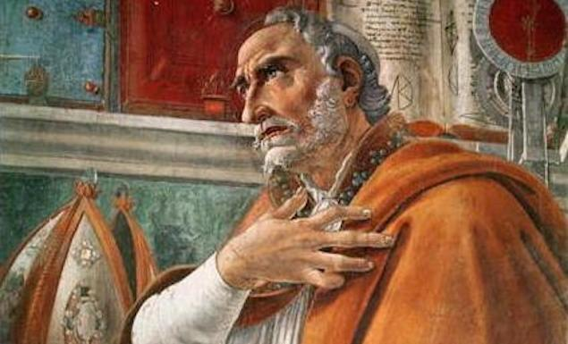
Augustine who, as late as 430AD, said of the Donatists (who advocated that the clergy must be faultless in order to administer the sacraments) reproached the church for using Divine songs while they “were inflaming their minds by singing songs of human composition”.
A number of Councils of the period denounced the singing of uninspired hymns. For example the Council of Laodicea, which took place sometime between AD 343 (according to Kenneth Stewart and 381 according to Michael Bushell). He quoted Canon 59 of the 60 canons of Laodicea as follows:
“No psalms composed by private individuals nor any uncanonical books may be read in the church, but only the Canonical books of the Old and New Testament.”
This finding was ratified by the Council of Chalcedon in AD 451. Joel Beeke, in “Sing a New Song” quoted from a number of the Church Fathers to show their enthusiasm for Psalm singing as follows:
- Tertullian (AD155-230): Psalm singing was not only an essential feature of the worship of his day but had become an important part of the daily life of the people:
- Athanasius (300-343) said that it was the custom of his day to sing psalms, which he called “a mirror of the soul” and went as far as to say “a book that includes the whole life of man, all conditions of the mind and all movements of thought.”
- Eusebius (c260-c340), bishop of Caesarea wrote: “The command to sing Psalms in the name of the Lord was obeyed by everyone in every place: for the command to sing is in force in all churches which exist among nations, not only the Greeks but also throughout the whole world, and in towns, villages and in the fields.”
- Basil the Great (c.330-379) commented in his sermons on the Psalms on the “harmonious Psalm tunes” that mix “sweetness of melody with doctrine” and are sung by the people not only in the churches but “at home” and “in the marketplace” as well.
- Augustine (343-430) in his Confessions (ix.4), wrote: “[The Psalms] are sung through the whole world, and there is nothing hid from the heat thereof.”
- Jerome (died 420) said that he learned the Psalms when he was a child and sang them daily in his old age. He wrote: “The Psalms were continually to be heard in the fields and vineyards of Palestine. The ploughman, as he held his plow, chanted the Hallelujah; and the reaper, the vinedresser, and the shepherd sang something from the Psalms of David. Where the meadows were coloured with flowers, and the singing birds made their plaints, the Psalms sounded even more sweetly. These Psalms are our love-songs, these instruments of our agriculture.”
- Sidonius Apollinaris (c431-c482) described boatmen in France singing “Psalms till the banks echoed with ‘Hallelujah’”.
- Chrysostom (died 407), the patriarch of Constantinople wrote of the widespread use of David’s psalms. Let me give one quote, recorded by Joel Beeke, “David is always in their mouths, not only in the cities and churches, but in courts, in monasteries, in deserts, and the wilderness. He turned earth into heaven and men into angels, being adapted to all orders and to all capacities” (Sixth Homily on Repentance).
During the Middle Ages congregational singing eroded and it became more and more common for monks to sing. This led to increasingly sophisticated tunes which most people could neither sing nor understand. Nevertheless Joel Beeke noted that Psalms still dominated the music and language of the church.
The Reformers did not all advocate the exclusive singing of Psalms. However psalm singing grew out of a desire to be make worship scriptural. This required psalm singing to be adapted away from the sophisticated chanting in monasteries towards more simple tunes that could be sung by the congregation.
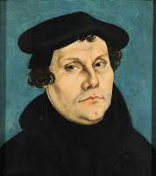
Luther, by no means an exclusive psalmist, was apparently the first to suggest that congregations should sing Psalms. He wrote a letter to Georg Spalatin describing his plan to develop vernacular psalmody “so that the Word of God may be among the people also in the form of music.” Under Luther’s guidance the first protestant hymnal was produced in 1524 (Gestliche Gesangbuchlein). “A Mighty Fortress is Our God” was an example of his work. This is a rendition of Psalm 46.
When the Marian exiles returned from Geneva to England they brought with them the Psalter, which in 1562 they expanded to include all 150 Psalms:
Knox, Whittingham, and others of the Puritan party of exiles who were deeply under Calvin’s influence, were particularly impressed by the Psalm singing which he had set up in his little French congregation. In preparing a service book for their own people to take the place of the prayer book, they determined to introduce Psalm-singing, and began the preparation of an English psalm book, of which Calvin’s French Psalter was inevitably the model. (p187 of Songs of Zion – Benson, The English Hymn, p26ff).
And what, we might ask, was the effect on others of the singing of Psalms? Let us consider one example. On 4th September 1582, John Durle, a minister of Edinburgh who had been exiled by James VI through the influence of Esme Stuart, Duke of Lennox, returned home. According to the historian Calderwood, some 2,000 Scots met him singing the 124th Psalm. The great sound and majesty of the sight so frightened the Duke that he hastily left the country, never to return (p188, Songs of Zion by Michael Bushell – taken from Reid, op cit pp52ff.
It has already been noted at the beginning of this article that Reformed Protestants were drawn to the Psalms. I have previously quoted from Calvin’s Preface to the Psalter of 1543:
“Moreover, that which St. Augustine has said is true, that no one is able to sing things worthy of God except that which he has received from Him. Therefore, when we have looked thoroughly, and searched here and there, we shall not find better songs nor more fitting of the purpose, than the Psalms of David, which the Holy Spirit spoke and made through him. And moreover, when we sing them, we are certain that God puts in our mouths these, as if He Himself were singing in us to exalt His glory.”
My own experience of singing psalms echoes the experience of Calvin and Augustine before him. I trust that these two articles may go some way to encourage the reader to explore
psalm singing and to experiment as I did at the Banner of Truth Conference in 2015 – so I end with Psalm 34:8:- “Taste and see that the Lord is good”.

Treasure in My Chest by Lorna Witter

I love the Lord, because He hath heard my voice and my supplications.
Psalm 116:1

I was praying to Him for help as I was diagnosed with breast cancer in August 2019 and having lost my husband suddenly from a heart aneurysm in January 2016, then having a miscarriage due to the shock of my husband’s death, not to mention going through the menopause, I made up my mind that I didn’t want to lose my breast or leave my children to go into hospital. My husband went into hospital and died there so I was afraid and decided I didn’t need to go into hospital.

My Pastor and many church members tried in vain to persuade me to have the mastectomy that was being offered and chemotherapy that would follow, but I stubbornly refused, rather taking the route of alternative medicine, believing that Jesus could heal me supernaturally and if I changed my diet to a vegan one, I could deal with this cancer without the help from the NHS.

Sadly, I deceived myself and my cancer became inoperable and had now in March 2022 started to fungate. The growth of the cancer was making me antisocial and I needed to apply constant dressings to the wound that was growing. t. I was crying out to Jesus for wisdom to know what to do next as I had run out of private medication and would need a blood test before I could pay for more.

My son’s boss who is a Doctor and Christian encouraged me to consider NHS treatment and my Pastor once again suggested I go back to the NHS and ask for chemotherapy.

Thankfully, God gave me grace to humble myself and I asked Him to forgive my sins of pride and a stubborn heart.

If we confess our sins He is faithful and just to forgive our sins and cleanse us of all unrighteousness. 1 John 1:9

I said sorry to my Pastor for not listening to his good advice and he graciously forgave me and prayed for God’s mercy and anointed me with oil.

The effectual fervent prayer of a righteous man availeth much. James 5:16

I called the NHS Breast Clinic to ask if they would be willing to help me.

They were very gracious and in no time at all they had me come in for scans and tests and arranged for district nurses to attend to me daily as my wound was huge and was now becoming so painful as it was growing so fast and touching nerves. I ended up in A&E needing morphine for a month to help me cope with the pain. I had lost so much weight by now; 54kg that a dietitian had to prescribe high calorie, energy drinks to help me nourish my body.

By now I couldn’t wait for the chemotherapy to start shrinking this awful tumour. Again the Lord was merciful and gracious and so tender in His dealings with me as all my scans showed no metastasis, because the tumour was coming out of my body not growing internally.

Chemotherapy finally started in May 2022 and wasn’t without it’s difficulties. I had an allergic reaction to one of the drugs, so they had to change it, I had an infection so had to go back to A&E for antibiotics. I developed a head rash which felt like my head was on fire and looked like hot, grey wax had been poured on my head.

Despite all these troubles, the Lord showed His gentle love towards me and my children in so many ways.

Our church praying daily for us, family & friends encouraging us, doctors, nurses, transport drivers, St Christopher’s Hospice giving us practical help, neighbours giving us various gifts and flowers.

The Lord Jesus has never left our side and has indeed allowed me to lean hard against His Mighty Presence as He has given me so much Joy to strengthen me.

My brethren, count it all joy when ye fall into divers temptations; James 1:2

The steroids given to help cope with the powerful drugs meant I was able to continue going to church and when they wore off, my daughters cared for me when I could do nothing except lie still and wait patiently for the dreadful side effects to wear off.

Be still, and know that I am God: Psalm 46:10

My journey to be cancer free continues, more scans await me and appointments with plastic surgeons, but where I was afraid to have the mastectomy and definitely afraid of chemotherapy, I have been given much grace and have now finished the chemotherapy treatment and I’m no longer afraid of surgery because Jesus is Lord of all and He has helped me to surrender to His perfect will for my life. My body is not my own so I know I can trust the Man who died for me.

I beseech you therefore, brethren, by the mercies of God, that ye present your bodies a living sacrifice, holy, acceptable unto God, which is your reasonable service. Romans 12:1

For of Him, and through Him, and to Him, are all things: to whom be glory for ever. Amen
Romans 11:36

Praise and Prayer Requests
For Praise:
- For increased numbers of visitors in the past few weeks at the Lord’s Day Services;
- For the continuing Friday Kids Club and Sunday School Work;
- Give thanks for Matthew Brinkley (LCM) helping us with street evangelism once a month;
- For an encouraging anniversary service in May and Kids day out in August;
- For the end of Lorna’s chemotherapy treatment;
- That the children of a local family have been returning from time to time;
- That two men from a local Nursing Home have begun attending the church;
- That there are now two new tenants in the flat.

For Prayer:
- Please pray that the Lord would send workers for the harvest field at Strangers Rest;
- Please pray for good fruit from the outreaches;
- Please continue to pray for Lorna as she faces an operation to remove the cancer (3 November) and recovery;
- Please pray that the children of a local family would increase their attendance and be converted;
- Please pray for our Guest Service on Sunday 11th December 2022;
- Please pray for D and A from a local nursing home, that they would understand the gospel and be saved;
- Please pray that the visitors would commit to the church;
- For fruit from evangelism.

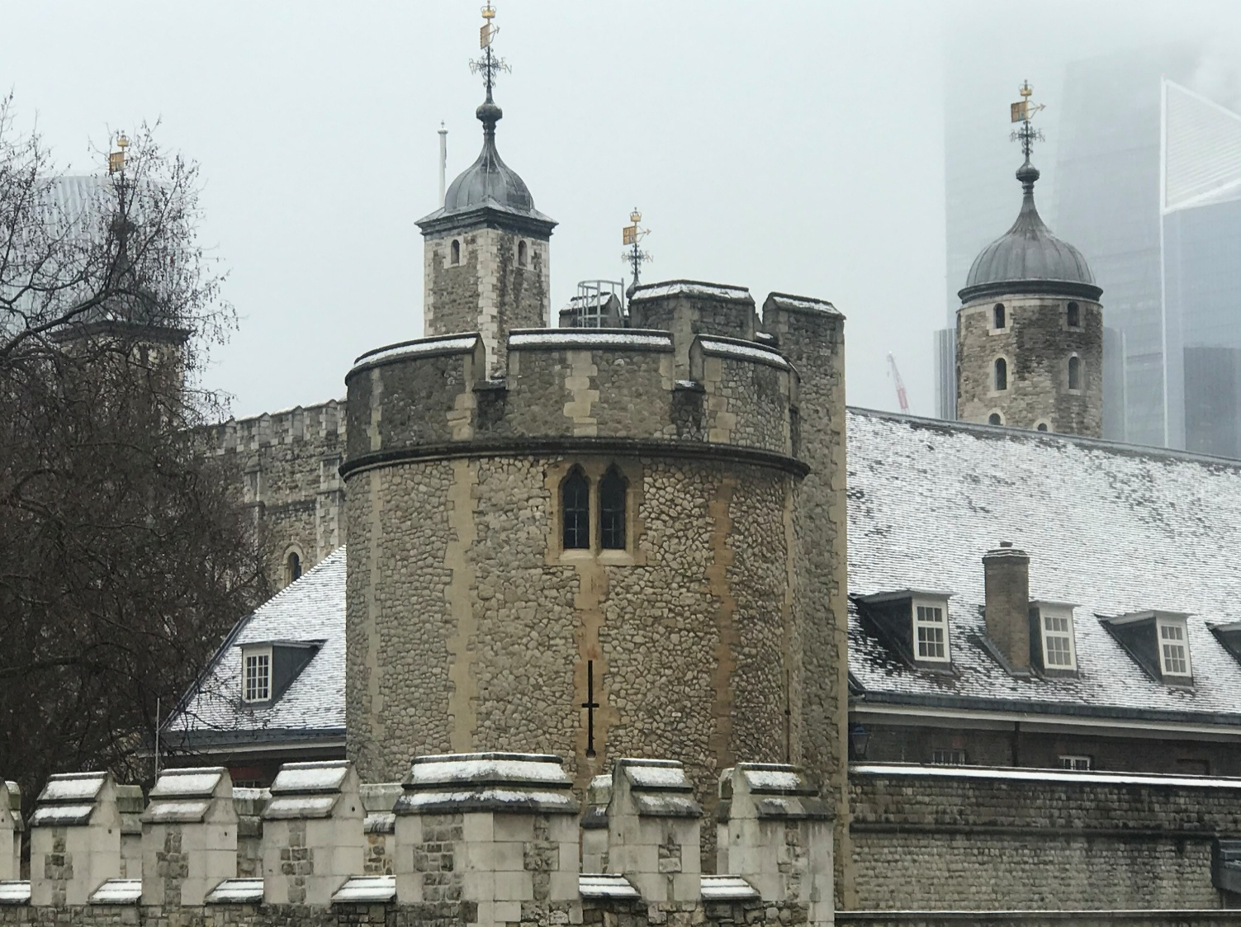
You are invited to our
Seasonal Guest Service
On Sunday 11th December 2022
At 11 am

Details:
Zoom
Meeting ID: 910-993-1031; Password: 667012
Or call 0131 460 1196 using the above details.

YouTube
Strangers Rest
https://www.youtube.com/channel/UCUV3ZmDVydcAFtZ6TCLGliA

Minister – Mark Mullins (minister.strangersrest@gmail.com)
Church Administrator (not attending Strangers Rest) – Angela Baker (abaker@strangersrestmission131.onmicrosoft.com)
Strangers Rest Evangelical Church, 131 The Highway, London, E1W 2BP; 0207 488 4427.
Services: Sunday Service 11:00am and 6:30pm; Wednesday Bible Study 7:00pm;
Friday Children’s Bible Club 6:30pm, Sunday School 4:00pm.
www.strangersrest.org

Biblical Praise by Jorge Ruiz Ortiz © 2017 by My Soul Concern Publications at page 22
Both these quotes are taken from “Songs of Zion” at pages 114-115 respectively by Michael Bushell
Calvin, John. Calvin's Complete Bible Commentaries (With Active Table of Contents in Biblical Order) (Kindle Locations 84111-84120).
Calvin, John. Calvin's Complete Bible Commentaries (With Active Table of Contents in Biblical Order) (Kindle Locations 116432-116434).
Calvin, John. Calvin's Complete Bible Commentaries (With Active Table of Contents in Biblical Order) (Kindle Locations 116549-116555).
Maclean, William; Balfour, Donald; Mackay, William; Keddie, John; Murray, David; Silversides, David; Vogan, Matthew. Songs of the Spirit: The Place of Psalms in the Worship of God . Reformation Scotland. Kindle Edition.
https://en.wikipedia.org/wiki/Clement_of_Alexandria
https://en.wikipedia.org/wiki/Paul_of_Samosata
https://en.wikipedia.org/wiki/Donatism#:~:text=Donatism%20was%20a%20Christian%20sect,and%20sacraments%20to%20be%20valid.
The quote comes from Ep. Ad Januarius; See Nicene and Post Nicene Fathers, First Series, Vol. I, p.315 – quoted in Songs of Zion by Michael Bushell at p159.

