To the law and to the testimony: if they speak not according to this word, it is because there is no light in them.
Isaiah 8:20

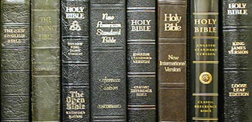
Over the past few weeks I have been considering the importance of Bible Versions. My enquiry began when I visited a small Baptist Church where the pastor spoke of the King James Bible as the inspired word of God in English. A few days later I later I attended a wedding where the pastor generously presented a Bible to the Bride and Groom at the end of the service. Symbolically this was an excellent present because it pointed the Bride and Groom to the only sure foundation for a successful marriage, namely God’s Word which is a lamp to unto our feet and a light unto our path (Psalm 119:105). I discovered later that the version of the Bible was the Message by Eugene Peterson which is a paraphrase translation seeking to convey the author’s understanding of the scriptures in today’s language. I do not believe, as you will as you read this article, that The Message is properly to be described as The Bible.

I was once more reminded of my own journey from the New International Version which I was given when I was born again in 1984. It was written in modern English and was therefore easy to understand yet I always felt that it was missing depth and majesty and seemed rather anaemic. In 1992 I was introduced to Intercessors for Britain who recommended the New American Standard Version which I read for a period. However, I was not satisfied with the English in that version and so I briefly tried the New King James Version which again I was not at home with before finally deciding to go back to the King James Version. I have stayed with it ever since.

A week before a Prayer and Bible week I attended, I had the unusual experience of dreaming that I was praying about what to speak about which, when I awoke, I concluded must refer to the coming Bible Week where I had been asked to speak so I continued to pray and then into my mind came “Bible Versions” and I knew I had my theme for the talks I was to give. I was greatly assisted in this task by Malcolm Watts’s excellent booklet, “The Lord Gave The Word” as well as The King James Defended by Dr Edward F Hills.

I started my study on the biblical evidence for the compilation of the Old Testament starting with Moses’s compilation of the Pentateuch. In Exodus 24:4 we are told that “Moses wrote all the words of the Lord”. In Numbers 33:1-2 it records that Moses made a written record of the journeys of the children of Israel. We read in Deuteronomy 31:25-6 that Moses entrusted the Levites who bare the ark to keep the book of the law that he had written in the side of the ark of the covenant. Through the Old Testament we see how God’s Word was added to by Joshua (Joshua 24:26-7), by Samuel (1 Samuel 10:25). 1 Chronicles 29:9 tells us that David’s acts were recorded, 2 Chronicles 9:29 of Solomon and 2 Chronicles 12:15 of Rehoboam.

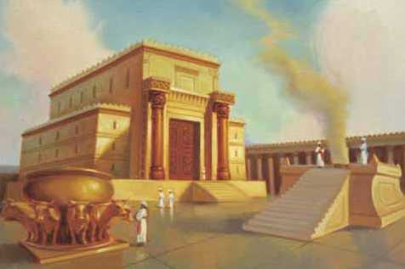
Once the Temple was built it is evident that the scriptures were kept in the Temple (2 Kings 22:8). Plainly the originals or autographs (as they are known) would not have been sufficient. Deuteronomy 17:18 tells us that copies of the law were entrusted to the priests. These duties then appear to have passed to the families of the scribes which descended from Rechab. The Rechabites were an unusual group of people because they drank no wine and dwelt in tents (Jerermiah 35:6-7). You may think that these are exactly the sort of people that could be entrusted to make accurate copies of the scriptures.

Copies of the scriptures must have followed the Israelites into exile in Babylon because Daniel quoted from Jeremiah and Moses’s law in Daniel 9: 2 and 11 respectively.

The scriptures survived the captivity and were read to the people by the Levites (Nehemiah 8). Many reliable copies survived and were available at the time of Jesus’s ministry. In Luke 4:16-17 the Lord Jesus read from one such copy in the synagogue in Nazareth. Indeed the Old Testament must have been freely available during Jesus’s ministry since he encouraged his hearers to read them for themselves (John 5:39).

The lesson of the Old Testament is that the scriptures were preserved by being stored next to the ark and then in the Temple. Following the destruction of the Temple the scriptures were preserved by God’s people in captivity and then within the nation of Israel.

We find that in the New Testament verses from the Septuagint (Greek translation of the Old Testament) are quoted. That is not to say that this authenticates the whole of the Septuagint. There are passages such as Matthew 2:15 are very different from the Hebrew in the Septuagint.

After the destruction of the Second Temple the Hebrew text was preserved by the Massoretes who had very strict rules of copying the scriptures. For example, three mistakes on a page meant the whole manuscript had to be destroyed.

The Lord Jesus promised that the Holy Spirit would guide the apostles in the writing of scripture bringing to their mind the things the Lord had taught them and showing them things to come (John 14:26 and 16:12-13).

The New Testament authenticates itself in a number of interesting ways. Peter confirms that Paul’s letters are scripture and that he had read them, indicating copies were available (2 Peter 3:15-16). Paul quotes from Luke 10:7 (the labourer is worth of his reward) in 1 Timothy 5:18 and attributes to it the status of scripture, thus authenticating Luke’s Gospel and by implication, Acts.

The majority Greek manuscripts of the New Testament that are still available today are grouped together and called the Byzantine text because they were found in the Eastern part of the Roman Empire. These texts originated in Antioch (where the disciples were first called Christians – Acts 11:26) which was a church centre from which Paul set out on three of his missionary journeys (Acts 13:1-3, 15:35-6 and 18:22-3). Consistent with the principles of preservation in the Old Testament we find the scriptures being preserved through God’s people (the priesthood of all believers (1 Peter 2:9). Paul’s instruction to Timothy was to commit the things he had taught him to faithful men able to teach others (2 Timothy 2:2). We would expect that the New Testament scriptures would have been committed to faithful men in the same way. It is estimated that approximately 90% of the Greek manuscripts still in existence represent the Byzantine text-type.

It was from this text-type that Desiderius Erasmus compiled his version of the Greek New Testament in 1516. It is suggested in some circles that Erasmus, being a Roman Catholic humanist was unreliable as a translator. However this quote from Paraclesis would suggest that his motives were precisely those of the reformers he preceded (taken from Schaff’s “History of the Christian Church” (Vol 4) at p723):
Desiderius Erasmus

“I utterly dissent from those who are unwilling that the sacred Scriptures should be read by the unlearned translated into their own vulgar tongue, as thought he strength of the Christian religion consisted in men’s ignorance of it. The counsels of kings are much better kept hidden but Christ wished his mysteries to be published as openly as possible. I wish that even the weakest woman should read the Gospel and the epistles of Paul. And I wish they were translated into all languages, so that they might be read and understood, not only by Scots and Irishmen but also by Turks and Saracens. I long that the husbandman should sing portions of them to himself as he follows the plow, that the weaver should hum them to the tune of his shuttle, that the traveller should beguile with their stories the tedium of his journey.”

It has rings of William Tyndale to it when he told a Roman Catholic priest that he would “cause the boy that drives the plough to know more of the scriptures than you”!

It has been said of Erasmus’s work that it was hurried and that he did not have access of the Greek texts available to us today. This is a reference to the lack of representation of the Alexandrian text type associated with Alexandria in Egypt in his Greek compendium. The two representative texts associated with the Alexandrian family are Codex Vaticanus and Codes Sinaiticus. Codex Vaticanus was discovered in the Vatican library which was established by Pope Nicolas V in 1448. It is listed in the earliest catalogue in 1475. According to Frederick Kenyon in “Our Bible and the Ancient Manuscripts” at p138 of the 4th edition:

“A correspondent of Erasmus in 1533 sent that scholar a number of selected readings from [Codex B – Vaticanus] as proof [or so says that correspondent] of its superiority to the Received Text. However Erasmus appears to have rejected Codex Vaticanus as unreliable. While Erasmus may not have had access to the Greek manuscripts discovered in the centuries after he wrote his Greek New Testament, according to Frederick Kenyon, well over 90% of those documents support the Byzantine text compared to Vaticanus and Sinaiticus.

Robert Estienne, a printer, (known as Stephanus) edited the New Testament four times between 1546 and 1551. The third edition of Estienne was used by Theodore Beza (1519–1605), who edited it nine times between 1565 and 1604. The term Textus Receptus comes from the publisher’s preface to the 1633 edition produced by Bonaventure and his nephew Abraham Elzevir which reads, “so you hold the text, now received by all, in which (is) nothing corrupt”. Over time this term has retrospectively been applied to Erasmus’ editions, as his work formed the basis of those that followed.

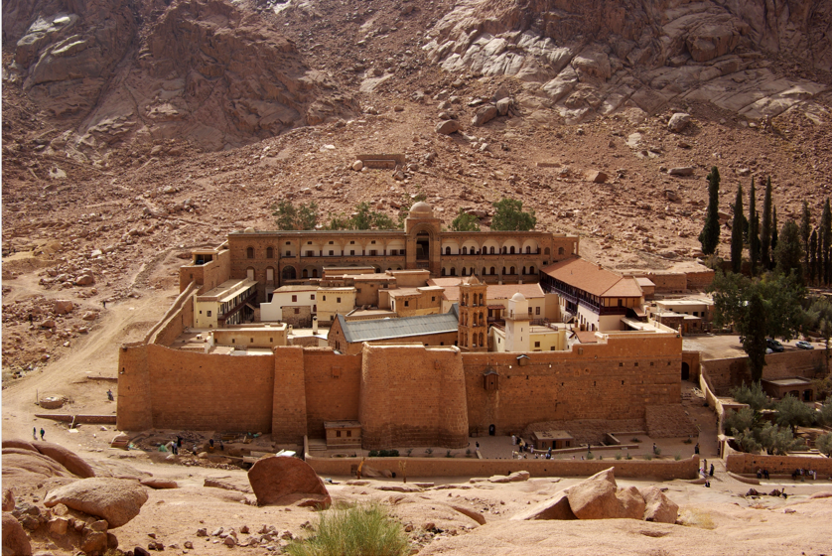
In 1844 Constantine Von Tischendorf discovered some pages taken from Codex Siniaticus which he found in the wastepaper basket in St Catherine’s Monastery on Mount Sinai. It is considered, like Codex Vaticanus, to be of Alexandrian origin. It is worth noting that there was never an apostolic presence in Egypt. On the contrary it was known for Gnostics so that any texts proceeding from Egypt should be treated with suspicion. These principle manuscripts disagree with each other in thousands of places. Both the Sinaiticus and Vaticanus are in very good condition considering they both date back to the 4th Century suggesting that they were rejected as flawed and not used by the early church. Accurate manuscripts of that period would have perished from use like any well used Bible we might use today.
St Catherine’s Monastery

In the last century two Cambridge scholars, BF Westcott and FJA Hort introduced a new theory about the early transmission of the New Testament. They suggested that the best text was actually the Alexandrian text represented by Codices Sinaiticus and Vaticanus. As these manuscripts were slightly earlier than the others they claimed that their common ancestor was close to the inspired original.

They stated at p225 of their book,

“It is our belief (1) the readings of Aleph B (Vaticanus) should be accepted as the true readings until strong internal evidence is found to the contrary, and (2) that no readings of Aleph B (Vaticanus) can safely be rejected absolutely, though it is sometimes right to place them only on an alternative footing, especially where they receive no support from Versions or Fathers”.

They believed that the Byzantine text (which they called the Syrian text) contained “conflate readings” which are combinations of earlier readings which they believe originated in a two-stage revision produced at or near Antioch in the fourth century. This was mere speculation on their part which they advanced on the basis that the growing diversity and confusion of Greek texts led to an authoritative revision at Antioch and later to a second authoritative revision which was completed by 350AD. They even suggested that Lucian of Antioch who was martyred in 312 may have been involved in the earlier revision although they had no evidence for this suggestion.
On the basis of their studies, Westcott and Hort prepared a revised Greek text. A proof of this text was made available to the committee appointed by the Convocation of Canterbury in 1880 to prepare a revised edition of the King James Bible. This rather than the Greek texts relied on by Erasmus was generally followed in the Revised Version of the English New Testament. Westcott and Hort’s Greek New Testament was the forerunner of the Nestle Aland (United Bible Societies Text).

The result has been that a number of verses have been changed in the modern versions by following the Nestle Aland Greek New Testament. Space does not allow me to quote more than a couple of examples. A key example is 1 Timothy 3:15. In the King James Version it is translated:

“And without controversy great is the mystery of godliness: God was manifest in the flesh, justified in the Spirit, seen of angels, preached unto the Gentiles, believed on in the world, received up into glory.” This is one of those key verses that expressly and categorically states that the mystery of Godliness is that God was manifest in the flesh and therefore plainly affirms the deity of Christ”.

Yet, following the Nestle Aland text, the English Standard Version and the New International Version have substituted “he” for God thus diluting this great statement of the Deity of Christ removing its clarity and allowing those who seek to deny the Deity of Christ to remove one of the clearest signposts to Christ’s divinity.

The Nestle Aland text bracket the last 12 verses of Mark. While the ESV and the NIV both include the verses, nevertheless they both include the following caution. The ESV states: “Some of the earliest manuscripts do not include 16:9-20 while the NIV states “the earliest manuscripts and some other ancient witnesses do not have verse 9-20”. The New King James states: “Mark 16:20 Verses 9–20 are bracketed in NU-Text as not original. They are lacking in Codex Sinaiticus and Codex Vaticanus, although nearly all other manuscripts of Mark contain them”. The Message brackets the text and states: “the portion in brackets is contained only in later manuscripts.”

We can see that each of these modern versions has repeated the flawed logic of Westcott and Hort that the oldest manuscripts are the best without regard to their origin, their disagreements with the majority Greek texts or the presence of faulty manuscripts from the earliest of times arising from the heresies that abounded at the time of the Apostles themselves.

Even where the modern versions have followed the Textus Receptus, by adding footnotes which question the majority Greek Texts, they sow confusion and create doubt amongst believers about the authenticity of the contested passages. Most believers are ill-equipped to investigate the manuscript evidence for themselves.

Defenders of modern versions contend that the doctrine of these contested verses is preserved in other parts of the Bible. However, the problem is that those who wish to twist scripture have increasing liberty with every concession made to the Greek translations based on Sinaiticus and Vaticanus. False teachers, after all, do not refer to the whole Counsel of God, but to individual verses that support their view. This is made easier by the preference given to the Alexandrian texts in the modern versions.

The Muslims claim that our Bible has been corrupted. However, God has promised to preserve His Word and this is what He has done through the centuries in the Textus Receptus and the Massoretic Texts. The attempts of the modern textual critics to undermine the majority Greek manuscripts that have been preserved and passed down to our generation should not shake our confidence that we have access to accurate copies of the original divinely inspired texts.

The King James Bible (aka Authorised Version) is based solely on the Textus Receptus and is generally considered to be an accurate translation where both the grammar and the patterns of the formation of grammatical sentences (Syntax) have been preserved by using the technique of formal equivalence. This is not to say that the King James translators were divinely inspired. No one but the original authors can claim divine inspiration. However, just as the parts of the Septuagint that were correctly translated were quoted in the New Testament as being the Word of God so the accurately translated passages of the Textus Receptus can also be held up as the Word of God.

I appreciate that there are linguistic difficulties with the King James Bible but these are by no means insurmountable. There is value in keeping the Thee’s and Thou’s because they distinguish between the second person singular and the second person plural which can make a difference. For example in John 3:7 the Lord says to Nicodemus: “Marvel not that I say unto thee, Ye must be born again”. All the modern version except the New American Standard Bible use You throughout and therefore the distinction is lost to the detriment of the rendition of the Greek. The use of the distinctive Thee in this example clarifies that it is all of us who must be born again and not just Nicodemus. Similarly in Luke 22:31-2 where the Lord Jesus says to Peter, Simon, Simon, behold, Satan hath desired to have you, that he may sift you as wheat: But I have prayed for thee, that thy faith fail not: and when thou art converted, strengthen thy brethren. In the first clause, the Lord, while warning Simon Peter, clearly means all the disciples (you). However, His assurance of prayer and the beneficial outcome of Peter’s fall, is for him in particular (thee … thou … thy).

I would like to end my article with a quote from the late Martyn Lloyd Jones in favour of retaining the Authorised Version:-
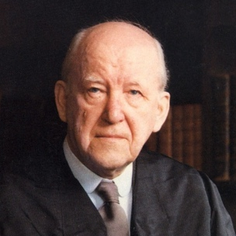
We are told that the Bible must be put in such simple terms of language that anybody taking it up and reading it is going to understand it right away. My friends, this is sheer nonsense. What we must do is educate the masses of the people up to the Bible not bring the Bible down to their level. One of the greatest troubles today is that everything is being brought down to the same level; everything is cheapened. The common man is made the standard of authority; he decides everything, and everything has to be brought down to him... we need to do is not to replace it...we need to reach and train people up to the stand and the language, the dignity and glory of the old Authorized Version.

Downloadable from http://www.tbsbibles.org/pdf_information/28-1.pdf

